**DAY ONE:**

Welcome to Operation Silver!    
We are SO excited to get to partner with you over the next 6 weeks and watch as you are transformed by this process. Let's get started!

**Part 1**  
Listen to this 35 minute audio about How to Generate an Income with Young Living- <http://stme.in/iRGUsL7ZP>.

PLEASE NOTE on listening to these from a tablet or phone:  If you are clicking a link from the Facebook app, you will need to open it in your device’s actual browser.  Click on any icons (like an arrow or square or three dots in a line) that will redirect you to a browser.  Many times people will write in and say the link won’t open and this is the reason why.  it needs to be opened in the browser and not in the Facebook app.    
  


**Part 2**  
Define your WHY.    
Your “why” is your long term vision for success in your business. Clinging to your “why” will help you manage your emotions and expectations.  Look at it often!  Type out and SAVE your WHY somewhere to your hard drive so you can find it easy later in your Operation Silver Folder.  Your WHY can also be a WHAT or a WHO.  But it boils down to WHY you are doing this.  We will revisit this concept often throughout bootcamp.

**Questions to help you discover YOUR "why"-**

* Why do you want to generate an income with YL?
* What are your current financial goals?
* What would that income do for your family and beyond?
* What would you do with an extra $500 per month? What about an extra $5,000 per month?  Now, let's dream REALLY BIG here..what about $30,000 per month?  It seems unfathomable but we want you to really dig deep and DREAM here...what would you do with that income?
* Write it down and hang it on your bathroom mirror.  Read it/say it daily!

**Part 3**  
Network marketing expert, entrepreneur and self made millionaire, Sarah Robbins, has an excellent blog post on why it’s important to “define your WHY”.  GO to the link below and scroll to the middle of the page and read "The WHY behind the What---the importance of knowing your reason WHY in network marketing".  Read it here: <http://www.sarahrobbins.com/managing-emotions-expectations/>

**Part 4**  
YL Fast Track is a team of 2 Royal Crown Diamonds and 2 Crown Diamonds that have formed to bring training, support, and encouragement on both product education and business building to all of Team YL. Go “like” the YL FAST TRACK Facebook page and share it with your teams.  It's a very valuable resource in building a Young Living business!    <https://www.facebook.com/YLFasttrack>

**SQUAD MEMBERS:**  
1.  Get to know each other in your Facebook groups you have formed! Post a 1 minute video telling the group all about YOU!  Tell everyone who you are, where you are from, what you enjoy, etc.  If you want to just type it out and post it in the comments, that’s ok too!  
2.  Share your WHY.  Comment in the Facebook group with your WHY. As you read each other’s comments, feel free to dialogue and interact- the group will be much more enjoyable if we encourage one another and build friendships.  
  
**CADETS:**  
1.  Write out your story in a notebook.  What is your background?  What circumstances led you to discover essential oils?   
2.  Write your WHY in the same notebook.  What is your motivation and drive to share these oils and generate an income with Young Living?

|  |  |
| --- | --- |
| |  | | --- | | **SQUAD** members, since you're going through this bootcamp with others in a Facebook group, post your answers to the discussion questions there.  This will build community, accountability and beautiful crossline relationships over the next 6 weeks. |   **CADETS**, get a notebook that you can write out the question and an answer to each day's Discussion questions. This notebook will be an excellent reference for you as you learn and grow in your business. |

**DAY TWO:**

|  |
| --- |
| Yesterday we defined our WHY and learned some steps to take to start loving and sharing with people. Remember the part of the call yesterday when I asked you to think about your number and then multiply it times 10? And then double that? Have you thought about that bigger number since  then? Have you pondered what that income could do for your family? For your community? For humanity? Have you challenged yourself to dream BIG?!  What IS your dream? Think back, WAAAAY back, like decades back, and remember your dreams.  What were they? What are they now? What have you lost sight of along the way? What may have seemed unattainable and has been put on the back burner for too long? What would you do if money was no issue? What would life look like if you could do what you love? Write it down! Write a word representing your dream on a post­it­note and stick it on your bathroom mirror. Remind yourself everyday of your dream. |
| Part 1­ |

|  |  |
| --- | --- |
| |  | | --- | | Post  2 |   Today we are going to "TEST YOUR DREAM".  Listen to THIS YL Fast Track call Diamond leader, Jen Jordan, recorded in 2014 based on John Maxwell’s teachings on “Building the Dream" (35 min)  http://stme.in/xP4Qyq6KD |

|  |
| --- |
| DISCUSS |
| 1. Write down and then share your DREAM. How it is married to to your WHY? 2. What was/were the most impactful questions about your dream in the call? 3. How are your EXCUSES killing your dream? |

|  |
| --- |
| SQUAD members, if you're going through this bootcamp with others in a Facebook group, post your answers to the discussion questions there.  CADETS, get a notebook that you can journal in.  Write the question and an answer to each day's Discussion questions. This notebook will be an excellent reference to lean on in the future as your business grows. |

**DAY THREE:**

|  |
| --- |
| You’re doing it! You are halfway through your first week! =)  Today you’re going to learn about a lot of different topics. You’ll learn about setting a short term goal, not being the expert, making a list of resources, and other valuable lessons. You’ll also hear how WHO you share with determines your first step. Get out your pen and paper, because you are going to want to take notes! |
| Part 1­ |

|  |
| --- |
| Listen to this 15 minute call­ |

<http://stme.in/2YJOMnB5s>

|  |
| --- |
| Part 2 |

|  |
| --- |
| https://gallery.mailchimp.com/456e6897822452d2e7f6afdea/images/c4d1b622-34c0-4e63-ad9a-4cf577e6f63a.jpg Make a commitment right now to build relationship with 30­-60 warm market contacts over the next 30-60 days. That’s ONLY 1­-2 people a day. Plant seeds now. Watch them grow in time.  Don’t try to sell.  Don’t try to present.  Just LISTEN. Listen and wait for the need to present itself, then offer the solution and schedule a get together/class. This is so easy with oils! “Your kids need immune support? I’d love to share with you some alternative health solutions I’ve been researching! When can we meet for a hot tea?” “You are looking for ways to maintain a healthy weightl?” “You’re husband is wanting to find ways to support a healthy respiratory system?” “You are trying to learn about eliminating chemicals from your personal care products?” “You are buried in student loans?” “You want to travel more?” “You hate your job?” Guess what y’all?! WE HAVE THE ANSWER! And we can share it with them because WE LOVE THEM and it is in their best interest to know!  The best thing about Young Living is that WE ARE NOT SELLING! Selling is pushing a product, creating the sense of a need, then filling that need. With the oils, the need IS ALREADY THERE!. People need wellness support.. We have the chance to encourage people with a healthy, natural option. Find the need and present the solution­ it’s that simple! |
| Part 3 |

|  |
| --- |
| RESOURCE ALERT  ONLINE RESOURCES FOR OILY PRODUCTS & REFERENCE MATERIALS. |
| |  | | --- | | www.abundanthealth4u.com  www.lifesciencepublishers.com  www.crowndiamondtools.com | |

|  |
| --- |
| BUSINESS ­BASED READING |
| |  | | --- | | *25 to Life by Adam Green*  http://25tolifebook.com    *Circle of Success by Monique McLean*  http://shop.youinfuse.com    *Driven for Success: Roadmap to the Compensation Plan by Jake Dempsey*  http://www.imdrivenforsuccess.com    *Road to Royal: Roadmap to Success by Debra Raybern*  http://growinghealthyhomes.com/road-to-royal/    *The Business of the 21st Century by Robert T. Kiyosaki*  http://www.thebusinessofthe21stcentury.com    *Rock Your Network Marketing Business by Sarah Robbins*  http://www.sarahrobbins.com/store/rock-your-business/    *GoPro by Eric Worre*  http://networkmarketingpro.com/gopro/    *4 Year Career - Young Living Edition  by Richard Bliss Brooke*  https://blissbusiness.com/Store/Products/9448.aspx    *First Steps to Wealth by Dani Johnson*  http://shop.danijohnson.com/first-steps-to-wealth/p/138514    *Building an Empire by Brian Carruthers*  http://www.buildinganempirebook.com | |

|  |
| --- |
| SUGGESTED BUSINESS BUILDING TOOLS |
| |  | | --- | | <http://crowndiamondtools.soundconcepts.com>    <https://vimeo.com/youngliving> | |

|  |
| --- |
| SUGGESTED YOUTUBE CHANNELS & FACEBOOK PAGES  (Subscribe to and Like Your Favorites!) |
| |  | | --- | | *Young Living Essential Oils*  <https://www.youtube.com/user/youngliving007>    *YL Fast Track*  <https://www.facebook.com/YLFasttrack>  AND [www.ylfasttrack.com](http://www.ylfasttrack.com) (PW is ylfast)    *Licensed2Live*  <https://www.youtube.com/channel/UC_a8Idv_jl_dSLRWRZ81-0g>    Hannah Crews  <https://www.youtube.com/channel/UCLMTacWwGdyUjzDq8smQklw>    *Alana Bookhout*  [*https://www.youtube.com/channel/UC5GjBZWlvO-ZHaEB3d243XA*](https://www.youtube.com/channel/UC5GjBZWlvO-ZHaEB3d243XA)    *Dr Jim Bob Haggerton*  <https://www.youtube.com/channel/UCp_-RT7nxEJfTS2dx_wiscA>    *Oola*  <https://www.youtube.com/user/OolaLife>    *Rob & Alina Rinato*  <https://www.youtube.com/user/SetYourOwnSail>    *Choosing Healthy Life*  <https://www.youtube.com/user/ChoosingHealthyLife>    *Jihan Thomas*  <https://www.youtube.com/user/JihanThomas>    *Educate Yourself Health*  <https://www.youtube.com/user/LaurenBrollier>    *ZYTO Technology*  <https://www.youtube.com/user/ZYTOtechnology>    *WiseChoiceLiving (Connie McDanel)*  <https://www.youtube.com/user/wisechoiceliving>    *Eric Woree*  <https://www.youtube.com/user/ericworre>  *Dani Johnson*  <https://www.youtube.com/user/danijohnsonvideo>    *Mastermindevent*  <https://www.youtube.com/user/MastermindEvent> | |

|  |
| --- |
| ****DISCUSS­**** |
| 1. What is your short term goal that you would you like to see happen THIS month? 2. How can you be intentional about talking to 1­-2 people everyday? Who are these people in your journey in life? (family, friends, teachers, coaches, etc)   |  | | --- | | SQUAD member, if you're going through this bootcamp with others in a Facebook group, post your answers to the discussion questions there.  CADETS, get a notebook that you can write out the question and an answer to each day's Discussion questions. This notebook will be an excellent reference for you as you learn and grow in your business. | |

**DAY FOUR:**

What is the goal of your initial contact with cold market vs warm market?Today we are going to explore HOW you can share.  We will also learn how the words we choose will greatly affect how people respond to us.

**Part 1-**

Listen to this call about what to say and what NOT to say.  You will hear about how choosing better words can help people hear your message more clearly as well as why some words and phrases are completely off limit because of FDA compliance.

Listen (27 minutes): <http://stme.in/23HzVqKRl>

**Part 2-  
Watch: Say THIS, not that:**[https://www.youtube.com/watch?v=ouiuRDfCUHk](https://l.facebook.com/l.php?u=https%3A%2F%2Fwww.youtube.com%2Fwatch%3Fv%3DouiuRDfCUHk&h=fAQEOTFsz) **Part 3-   
Listen to this 15 minute call to learn about warm and cold markets and how our goals with each are different.**<http://stme.in/iNuq4lXWT>

**DISCUSS**

1. Before today, were you aware of the power of the specific words you choose?  What do you think about being intentional with what words you do/don’t use?  How do you feel when friends talk to you about their “business opportunities”, etc?
2. Do you understand FDA compliance?  Are you using resources to empower and equip yourself?
3. What is the goal of your initial contact with cold market vs. warm market? (hint: this was covered in the lesson today)

|  |
| --- |
| SQUAD members, if you're going through this bootcamp with others in a Facebook group, post your answers to the discussion questions there.  CADETS, get a notebook that you can journal in.  Write the question and an answer to each day's Discussion questions. This notebook will be an excellent reference to lean on in the future as your business grows. |

**DAY FIVE:**

It is time to dive in and start experiencing what it is like to generate income with Young Living!  The first part of that is to understand how we get paid.

Today we are going to tackle the Young Living Compensation Plan.  Buckle your seatbelts!

**Part 1-**

Watch this 35 minute video- <https://www.youtube.com/watch?v=gjgP5em5X1A>



**Part 2-**

RESOURCE ALERT!

Here are some other GREAT resources to help you learn the compensation plan.  Bookmark these so that you can come back to them later.  You’ll want to watch SEVERAL different explanations over the next several weeks/months.

*Income Disclosure Statement*

<https://www.youngliving.com/en_US/opportunity/income-disclosure>

*YL’s 30 minute Vimeo about the comp plan*

<https://vimeo.com/106311888>

*Crown Diamond, Jake Dempsey’s 6 minute video on Generations*

<https://www.youtube.com/watch?v=zKrUC7EWUu0>

*10 minute comp plan video*

<https://www.youtube.com/watch?v=T9Mw-e5w9DE>

**DISCUSS**

1. What did you learn about the comp plan that you didn’t know before?
2. What questions do you still have about how we get paid?

|  |
| --- |
| SQUAD members, if you're going through this bootcamp with others in a Facebook group, post your answers to the discussion questions there.  CADETS, get a notebook that you can journal in.  Write the question and an answer to each day's Discussion questions. This notebook will be an excellent reference to lean on in the future as your business grows. |

**DAY SIX:**

Welcome back to Operation Silver!    
Today we are learning about building your structure as you enroll people.  This is a HUGELY important concept to grasp, so make sure you are bookmarking ALL of these links to come back and listen/watch again and again. Different leaders build in different ways. If you ask any Diamond how they got to diamond in terms of structure you'll hear multiple answers. Today we will discuss two ways. One is by placing all new members on your level 1 and waiting for 6 of them to catch the vision of the business and their leaders doing the same. It takes longer than the next way we will discuss but many leaders have built that way. The second way to build is by strategically placing people in your six legs needing volume to take you to Royal Crown Diamond. This is how our CEO designed the comp plan. This strategy can build your business/paycheck quicker and the beautiful thing is it gives new members multiple leaders to lean on. Always, always, always introduce new members to their upline leaders when placing someone in a particular leg. Whether you keep enroller status or give it away is up to you. New members will feel loved on, supported and feel they have a great team to lean on for both product knowledge and business help when they are in direct relationship with a few upline leaders. It really promotes TEAM spirit too!

## Part 1-

Listen to this call to learn how you can structure your organization as you enroll new members.  <http://stme.in/9xKG40cQ5> (20min)

## Part 2-

Listen to this call where six leaders, Platinum to Royal Crown Diamond, share what Strategic Placement has done for them, their teams, and their leaders.

<http://stme.in/mpMNyJs2A> (35min)



## DISCUSS

1. How have you been structuring your legs that you are building?  
2. Do you feel the way you are building now is maximizing the comp plan?

|  |
| --- |
| SQUAD members, if you're going through this bootcamp with others in a Facebook group, post your answers to the discussion questions there.  CADETS, get a notebook that you can journal in.  Write the question and an answer to each day's Discussion questions. This notebook will be an excellent reference to lean on in the future as your business grows. |

**DAY SEVEN:**

Today we are going to learn about your Virtual Office (VO).  Your VO is an amazing tool for growing your organization.  There is a wealth of information available to you there, as well as some great training tools.

**Part 1-**

When you sign into your YL account, there is a member resources tab with LOTS of great training material.  Watch these short videos to get familiar with the website, your account, and your downline viewer.

If you created your YL membership  before July 2014 and have not yet migrated to the new VO, start with this video to learn how to move from the old website to the new one- (2 min)

<https://static.youngliving.com/vo/training/videos/migration.mp4>

If you don't know how to place a quick order, watch this short video to learn how- (2 min)

<https://static.youngliving.com/vo/training/videos/placing-an-order.mp4>

Watch this video for a quick training on how to manage your organization in your downline viewer- (2 min)

<https://static.youngliving.com/vo/training/videos/managing-your-organization.mp4>

Watch this video for a tour of your online account- (2 min)

<https://static.youngliving.com/vo/training/videos/my-account-tour.mp4>

**Part 2-**

RESOURCE ALERT!

Bookmark these resources to check out later!

Downline Viewer Training Webinar (55 min)

<https://static.youngliving.com/vo/webinar/downline-viewer.mp4>

**Part 3-**

CONGRATULATIONS!  You made it through your first 2 Modules of Bootcamp- Start & Experience!  We are so proud of all of you who are sacrificing time to invest in yourself through this curriculum.  Y'all are rock stars!  Keep going!  


**DISCUSS**

1. Did you learning something new about your online VO today?  If so, what?
2. Do you feel confident in knowing how to navigate the website, how to help someone set up their new wholesale account, and understanding the downline viewer?
3. What has been your favorite part of Bootcamp so far?  Are you seeing changes in yourself as you learn this material, discuss it with others, and implement it into your life?

|  |
| --- |
| SQUAD members, if you're going through this bootcamp with others in a Facebook group, post your answers to the discussion questions there.  CADETS, get a notebook that you can journal in.  Write the question and an answer to each day's Discussion questions. This notebook will be an excellent reference to lean on in the future as your business grows. |

**DAY EIGHT:**

## COMPLIANCE

WATCH these short videos on sharing YL in a compliant way:

  
READ-  
Sharing Young Living is a document that is the core of what we are legally allowed to "claim" about YL products.  It’s important to read this document in it’s entirety.  Come back to it in the following days and weeks to revisit it and pass along it’s content to your team members who are sharing Young Living to profit financially. If you are looking to make money with Young Living then it limits what we can "claim" as it falls under "Commercial Speech". (as opposed to Free Speech)

Sharing YL compliantly

https://static.youngliving.com/en-US/PDFS/sharing_yl.pdf

What we CAN say:

http://tinyurl.com/ocz8tsz

What we CAN’T say:

http://tinyurl.com/p9m8l6e

Listen to this 20 min call on Compliance:

http://stme.in/fg2MeXsAk

## DISCUSS:

**1. Give 3 examples of a compliant post you can post to your Facebook wall, page or group.**

# 2. Share how getting back to basics and not trying to cure, save, fix and rescue everyone you want to share with can benefit you. Hint: it means you don't have to be the expert and it empowers them to do their own research in their reference materials and on the web. Do you see the value in that?

|  |
| --- |
| SQUAD members, if you're going through this bootcamp with others in a Facebook group, post your answers to the discussion questions there.  CADETS, get a notebook that you can journal in.  Write the question and an answer to each day's Discussion questions. This notebook will be an excellent reference to lean on in the future as your business grows. |

**DAY NINE:**

## CONFIDENCE

Feel like you’re lacking in confidence to share the YL opportunity?    
Would you like to know the secret? Doing it, and doing it, and doing it! Did you know that REPETITION is what makes you confident over time? Having strong reasons also keeps you going. Be inspired on how you can build and maintain confidence right here in these 3 great videos:

<https://www.youtube.com/watch?v=LLu4If_RAO8> (6 min)

<https://www.youtube.com/watch?v=91LJzkm97iU> (6 min)

<https://www.youtube.com/watch?v=w-HYZv6HzAs>(13 min)

A lot of people are brand new to this business model and may not have the confidence they want to have to share the oils. That’s ok.  There’s lots of room to grow here.  
  
Listen to this call by April Pointer about building confidence. (18 min) <http://stme.in/pKjaQOlAo>  
  


## DISCUSS:

## 1. What was your biggest takeaway from today’s audio/video?

## 2. What are the 4 things you can do TODAY to get your confidence level up?  The beautiful thing is that as you become more confident in sharing, you’ll be more confident in other areas of your life too.  The personal development that comes from this business is amazing!

|  |
| --- |
| SQUAD members, if you're going through this bootcamp with others in a Facebook group, post your answers to the discussion questions there.  CADETS, get a notebook that you can journal in.  Write the question and an answer to each day's Discussion questions. This notebook will be an excellent reference to lean on in the future as your business grows. |

**DAY TEN:**

**INVITING PEOPLE TO CLASSES**

Like Brian Carruthers says in his book “Building an Empire”, the name of this game is "contacting people and inviting them" to classes or scheduling 1 on 1’s. One thing he emphasizes is LISTENING. We want to be great listeners. Asking a lot of questions and sit back and listen. When you sit back and let other people talk about themselves, their dreams, concerns, experiences, etc, they will leave that convo thinking they've just had one of the best conversations they've had in a long time. Why? Because they did all the talking about their interests, etc. Again, just sit back and listen because somewhere in there will be a need for our products or a financial need. Young Living has the answer for BOTH. BUT....we don’t want to be sales-y and put pressure on folks. Instead, we want to meet people where they’re at. Whether that’s getting or staying healthy and well or because they need some **$$$** NOW.

**WHAT DO I SAY?**

The answer is “F.O.R.M”. You FORM them. This acronym concept is taught in many to both small business owners (think hair or nail salons as they see many new clients) and big corporations to train employees on how to talk to people and get to know them. It's how to keep the conversation going. Ask people about their Family, Occupation, Recreational activities and then give them your Message. (FORM) This is such a great way to open up conversations and get right into listening mode. People love to talk about themselves. SO LET THEM! Much of this job we've given ourselves is relationship building; we get to do A LOT of listening to meet people where they are at.

**More on inviting people...**  
Successfully inviting people to classes, home parties or events is a skill. We all need to know how to do this effectively.  The best way to help someone else build a business is simple. You just model it for them. You set up events - which means 3-4 members bringing 3-6 guests (or they each bring 1, and you invite a few, etc.) Always encourage guests to bring friends. You can even incentivize them to bring friends. Offering something to raffle off or offering a sample of a product to the people who bring guests is a way to get guests there. A 2ml bottle with 40-50 drops of essential oil is a great little freebie to go home with for bringing friends to your class. Orange, Cedarwood, Tangerine, Spearmint, RC, and other oils in that price range along with a COMPLIANT graphic on ways to use that oil makes a great party gift! Try to choose an oil NOT in the kit because chances are, they’ll order the kit at the class or soon after. TIP: If it's a "hot" oil you sample out, always make sure they understand what "dilution" means, how to do it with their own olive or coconut oils they probably already have at home and what to do if an essential oil accidentally gets in their eyes. Sometimes, even experienced oil users forget that we just put Exodus II (a hot oil blend) on our feet when we go to rub our eyes because we are tired. Ouch! Letting them know to never use water in their eyes and to only use a carrier oil to take the sting out is pivotal. Adding that to the card AND telling them is a good idea.

As you get started sharing Young Living, you may be tempted to order oils on your own account for friends or family instead of leading them into getting their own wholesale account on your team.  Let’s discuss the pros and cons to having people order through you INSTEAD of getting their own account.

**PROS to people ordering through you instead of getting a membership:**

-you get more points if you're on Essential Rewards

-if selling retail you make more than you paid for it

- It let's someone try 1 oil (however this can TOTALLY backfire if they don't use it consistently and don't have the resources to know HOW to use it.

-Your friend thinks they are saving money by not getting the kit (however, the reality is that they really aren’t because of the incredible value of the PSK)

**CONS to people ordering through you instead of getting a membership:**

-If selling it at your cost/wholesale, you don't make any $ off the sale.

-It takes a lot of time you may not have to advertise, take orders, add to orders, calculate totals with tax and shipping, deliver to customers, not to mention the gas used to do so.  #timesucker

-Stats show that those without their own account order less often as they have to rely on someone else (basically making you like the Avon lady), coordinate times for pickup, etc instead of placing an order themselves in a few clicks on their own keyboard.

-Some have actually gotten mad at distributors when they find out later that they can have their own account for a great deal (premium starter kit) yet they've been paying retail (possibly) and feel they got jipped by not being told how to get their own wholesale account. We’ve seen it happen where some were so upset that when they do sign up, they enroll with someone else (YIKES!!)

-You make FAR less $$$ by people ordering through you as opposed to having their own account and making commissions on their own personal orders.

-People may back out of their order with you and you are stuck with their oil and out your $$$, unless you took the (even more) time to get their $ prepaid.

-You run the risk of  people not reordering oils through you because it was a pain to coordinate as everyone is busy these days.

As you can see, there are far more CONS than PROS to having others other through you instead of getting their own wholesale account.  Many times, members go through all of the headaches of ordering for people, experience everything above and that's when they figure out it was better their friend get their own wholesale memberships. It's similar to a Costco or Sam's membership only there's no annual renewal fee! Score! Interestingly enough, when someone starts with the kit they will probably take the time to learn the HOW TO's because they paid so much more for it than for just 1 oil.  It’s an investment to them so they'll want to learn.  Also, it starts them with a variety of a wellness cabinet and there is a much better chance to make a huge impact on their health and lifestyle in lieu of just 1-2 oils they bought from you.



CLOSING YOUR CLASS   
Does the benefit of the Essential Rewards points you earn by ordering for them outweigh the benefit of a cash check of $50/ person bonus commission for you for those who get a membership with a PSK? Is it worth the time put into it and do you have the time to put into it? No and No.  
When closing a class, we want it to be INVITING instead of anyone feeling PRESSURED…don’t you agree? Below you will find six ways to help you with wrapping up your classes and inviting guests to become a Young Living member.  

1. Make a comparison that your audience can relate to BEFORE explaining how they can get their hands on the oils. For example say, “That concludes all the essential oils the Starter kit. We just covered 11 powerhouses that make up the kit. I want to briefly emphasize that the results you heard about were with Young Living’s essential oils and not perfume grade oils bought at the grocery store.  
   Has anyone here ever tasted cheap wine or processed cheese spread before (raise hand)? Now, has anyone here ever had a fine wine or fine European cheese before (raise hand)?  Is there a difference? (Nod your head yes and they will follow suit) Yes, there is! Young Living is truly like the “fine wine” of essential oils and does not even compare to the cheap perfume grade oils in most stores.

1. You cannot purchase these quality oils in stores. YL doesn’t pay for advertising or a middle man; instead they educate their members as it keeps the information pure. It would be impossible to train every health food store worker on the amazing qualities of therapeutic grade essential oils. There is too much turnover in the marketplace to do so. This is why education is important to YL, it's why we hold classes, and why there are countless reference materials available to us from Life Science Publishers, Abundant health 4 U, Amazon and CrownDiamondTools.com. The best part is when you start using YL, you will get a team of people who will guide and support you at no extra cost. YL essential oils are valuable assets when it comes to our wellness arsenal and supporting VIBRANT health.

3.     SAVINGS.

People are looking for a cheaper yet effective way to maintain control of their health and finances. Our essential oils are healthy, safe and highly effective.  "Let me tell you how I have personally saved hundreds of dollars using these products, while getting BETTER RESULTS than I even used to with synthetic products! Since joining YL __ years/months ago, I have not had to purchase ANY of the following conventional items since then: toilet bowl cleaner, glass cleaner, carpet stain remover,  topical sports cream, furniture polish, purifying spray, perfume, fruit and vegetable wash. To top it off, essential oils offer support for all areas of the body as well.  We use them daily!"

4.   Mention personal reasons the oils have helped you and your family, focusing on why  *I* love the oils and want to share that blessing and build relationships, rather than “why *you must* love the oils and I just needs your $ today.  We are here to help people by sharing an amazing life changing product and they need to feel that.

5.  Let guests know they can get their kit paid for by sharing with 3-4 friends in the same month that they sign up. Emphasize that Young Living is the only one for you - you can go to the farms and be a part of the process!  
Say "If you were invited to this class by a friend or if you are my guest, we will be in the back to talk or will get in touch with you directly after the class to see if there's anything else you want to know" That way the ball is in YOUR court, not theirs. You’re not waiting on them to contact you...it’s the other way around and they'll be expecting you to contact them and follow up. It's good to have laptops or tablets AND enrollment forms at a class so people can enroll at the end. HINT: Always have enrollment forms as a backup in case internet goes down or isn't accessible.

6. After the class, if they didn’t enroll at the class, call them or message them (preferably call) and ask them how they liked the class, what was their favorite part, and lead them into purchasing a kit. You already told them you'd be calling to follow up so it won't be a surprise. This is also where our relationship factor plays in.  This isn’t a get rich quick thing.  It’s about truly impacting our world with health.   If they aren't ready THAT day, then say, “OK, If you change your mind, please don’t hesitate to call me. I'd love to show you the ropes. Would you like me to contact you about it later?”  If they say yes, then the ball is still in YOUR court. SO BUILD THE RELATIONSHIP.  That’s what this profession is all about.  Once they buy a kit that isn’t the end.  It’s actually just the start of a beautiful thing.  They'll get their kit and you can help them get started with it. It's a shame when someone gets a PSK and it just sits on the shelf because they don't fully know how to use it. So, PLEASE love on that little seed, nurture it, and grow it.  They need that.  Don’t forget about them just because they have their kit and some reference materials (we encourage everyone on our team to gift new members compliant reference materials so that they can have an “EXPERT”  to look things up in.  It is well worth the investment.  In fact, Richard Brooke advises investing 20% back into your business.  Compliant reference materials  are a great way to do that.)  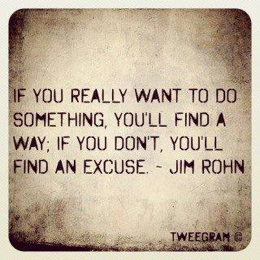

**Part 2**

Eric Worre, author of “*Go Pro”,*  says NEVER ask for questions at the end of an informational meeting. Why? The question itself engages the critical part of the brain and people who want to look smart will use it as a platform to challenge. People will naturally ask you genuine questions without you soliciting for them. That's ok.Then invite (instruct) them to the next step - where the computers are to sign up, where the printed calendar is to schedule a class they might like to host or attend, and send them on their way home. You can say, “I'll be back here to answer questions.” Otherwise a Q&A at the end of an info meeting is a black hole and deal killer. Then, when you are engaging people after the class, ask them, "What interested you?" or "What did you like best?"  or “What was your favorite part or favorite oil?” See how that stimulates a positive way of thinking instead of a negative or combative one?

Watch Platinum leader, Hannah Crews, as she talks about closing your class and inviting guests to join you on this amazing journey of essential oils. She's a pro at it! She makes people feel special.   
Closing a class isn't the end...it's merely the beginning of a beautiful lifelong journey of health and possibly wealth if they get into the business side. (16 minutes):

"Close with Confidence" <https://www.youtube.com/watch?v=UdZ7fPKPUuE>

**COMPARISON TRAP**

When you are feeling stuck in your growth, your pace or just feeling frustrated...do not (I repeat, DO NOT) go on Facebook or somewhere to compare yourself with someone else in their YL business. You don't know THEIR circumstances or THEIR “why”. Don't put yourself on THEIR timeline. It belongs to THEM. When you compare yourself to others, envy and jealousy will breed and can be death of your business. Comparison is the thief of joy and can be very, very toxic. Instead, be who YOU are. Go back to YOUR why. If you haven't already written down your WHY, so it today (and the wording above if you need it) and look at it every day...EVERY DAY! GO over the things YOU do to help your business grow. It will look different for each builder.  
  
It's the straight up truth that "Drama Kills Checks". Do you want to know how to increase your check and empower your team? Create a culture of UNITY and abundance and allow your team to plug into the leaders in your company that help them to grow! There's a lot of available crossline support out there open to the masses.  Let’s annihilate the spirit of competition and create a culture of collaboration on our teams!

#TeamYL

Watch the video “Collaboration vs Competition” below:

<http://www.sarahrobbins.com/collaboration-versus-competition/>  (Length 1 min 44 seconds)

**DISCUSS:**

1. What specific wording could you use to reach people to invite them to a class that will GET THEM THERE? Or if you think someone is ready right away for the business opportunity, what do you say? (this is RARE for YL leaders to lead with the opportunity as we are mostly product driven company but some do it and do it well). If you're in a Facebook group for bootcamp, read through the comments this may give you some ideas to add to your mental vault.

2.  How are you wrapping up your classes or one on ones?  Do you have any key wording or phrases that grab people to encourage them to get the kit right away?

SQUAD members, if you're going through this bootcamp with others in a Facebook group, post your answers to the discussion questions there.

CADETS, get a notebook that you can journal in.  Write the question and an answer to each day's Discussion questions. This notebook will be an excellent reference to lean on in the future as your business grows.

**DAY ELEVEN:**

One of Young Living’s Royal Crown Diamonds (Vicki Opfer) says, “Network marketing is different than retail marketing in a number of ways. Something that has been observed and proven within the industry is that however you introduce someone to your products is how they will share with others. If we enroll our friends, family, clients, etc., in a way that they cannot duplicate the next day, they will not share Young Living.” Excellent point, Vicki!

If we want to create successful businesses, we have to be very simple and duplicable when sharing, using an excellent and proven "duplication model" so that we don't "take away" our members' ability to share, if they should decide to do so. We've also discovered that almost everyone will want to share their successes with the products in some way with someone they know. However, only 5-10% will want to participate in the "business"...5% "to some degree" and the other 5% even more seriously.

As leaders, our job quickly becomes focused on helping the people in our organization share with their friends and family. If we do it in a duplicable way, the group begins to grow on its own. If we do it in a non-duplicable way, we're going to get very, very tired from carrying the load, we'll get burned out and possibly quit.

Duplication is required for the success of the network marketing business model. Duplication means people sharing with people, sharing with people...WITHOUT US. (Key words are - WITHOUT US.)

Vicki has shared that the way someone is introduced to YL is the only way they will know how to share the products. So what do you do?  Well, you KISS!!!

## https://gallery.mailchimp.com/456e6897822452d2e7f6afdea/images/e993bf72-0d08-48be-b53d-16821f6e4ee0.jpgK.I.S.S.

## Keep it Simple for Success

## Keep it Short and Sweet

## Keep it Short and Simple

## I think you get the point.

LISTEN: Have you ever been VERBALLY vomited on?  The visual makes you want to cringe, right? Unfortunately, that’s how others feel when we share way too much information about Young Living to people or even on our Facebook walls! We don’t want to be a fire hose and overwhelm people as EO's can get very, very complex. There's an oil for everything it seems and we have roughly 500 products. That's a lot!  Learn how to keep your business simple to be DUPLICABLE in this call by Royal Crown Diamond, April Pointer.  
   
Here’s how to “KISS” - Keep It Simple for Success (23 minutes):

<http://stme.in/JfOqI8aSr>

## WATCH:

Crown Diamond, Sera Johnson, shares how to "keep it simple" when introducing people to the Premium Starter Kit. She hits the nail on the head with this short demonstration of sharing the Premium Starter Kit. (19 minutes)

<https://www.youtube.com/watch?v=wDAmsLUsmrQ&feature=youtu.be>

## BONUS:

Young Living's farms are an experience of a lifetime! You have to experience it for yourself. We are the ONLY essential oil company that owns our own farms. That's pretty telling of how passionate we are about providing a truly 100% pure oil!    
How do you trust an industry that isn’t regulated? You go to the SOURCE yourself and learn how they do things. See it. Hear it. SMELL it. Touch it. Taste it. You can do all of this yourself at the farms. No one does what Young Living does. We are SUPER blessed!   
WATCH:  (1.5 minutes)  <http://vimeo.com/m/84724368>  
While you're at the farm, make sure to have someone take a photo of you jumping or leaping in the fields. These are priceless and great photos. Many years ago this trend was started by Royal Crown Diamond, Adam Green. We all followed his (super fun) example when he started posting photos of him doing this in the Lavender fields. SO EXHILARATING!

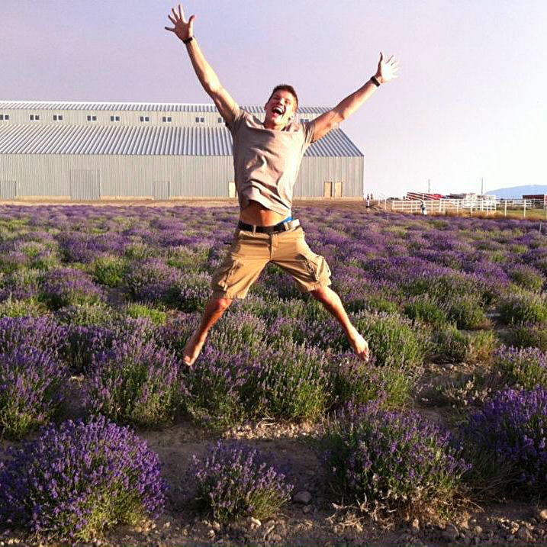

As you take off in your business, make Silver, Gold and Platinum Retreats YOUR GOAL!   You can earn an all expense paid trip that happens each year for those who rank up to Silver and above. Deadline qualifications can be found on YL’s website under Retreats. <https://www.youngliving.com/en_US/company/events/recognition>  
The following video is from summer 2013 when 150+ YL Silvers had the privilege of attending Silver Club in Idaho. We want to share the video from 2013 because of the member testimonials it provides. Silver Retreat is no longer held in Idaho and is now hosted in Utah at the farm there and by our corporate offices. Many of you are on track to get this same privilege of attending Silver Retreat this coming year but at the Mona, Utah farm! FUN! If you click on the Young Living channel in Vimeo you will be able to watch all the leader retreat videos on that channel.  Take some time to watch some of them this week or next.  Be inspired!  You could be on the next trip! Gold retreat is in Idaho now and Platinum retreat is held at our beautiful farm in South America in Ecuador.

Watch this video (7 minutes). https://vimeo.com/83859451  
  
Here's more current videos of the last few retreats of various ranks:  
<https://vimeo.com/133357777> SILVER #1 2015  
<https://vimeo.com/140682457> SILVER #2 2015  
<https://vimeo.com/136317557> GOLD 2015  
<https://vimeo.com/148291777> PLATINUM 2015

## TIP:   Use this quick custom link generator and save the link then share it with friends when you want to enroll them.  It will send them to the signup page and auto-populate YOU as their referral.   It’s recommended to only share the new VO link so people don’t have to migrate over later to the new VO.

<http://oilytools.com/yl-link-generator>

DISCUSS:    
  
1. Do you tend to be a fire hose when talking about Young Living or do you keep it simple. Share a story of when you shared "too much" and a story of when you shared "just the right amount" and the outcomes of each.  
2. After watching all of these videos today, discuss how you feel about attending these retreats.  Watching people in these videos get rewarded for their business building efforts, does that fire you up to do the work to be able to go on these retreats? Which one will you be on next?  
3. Would you consider going to Winter Harvest? It's not a recognition retreat and any adults/members can attend! It's a great way to experience our Highland Flats farm in Idaho in January or February each year at harvest time. Watch a video from 2015 here: <https://vimeo.com/119466920>

SQUAD members, if you're going through this bootcamp with others in a Facebook group, post your answers to the discussion questions there.

CADETS, get a notebook that you can journal in.  Write the question and an answer to each day's Discussion questions. This notebook will be an excellent reference to lean on in the future as your business grows.

**DAY TWELEVE:**

YOUR PRESENTATION   
Today we will delve deep into Your Presentation. You know, getting up in front of a group and sharing.  From what to wear, music to play but most importantly the words you speak.  This is specifically if you’re having a gathering of many people together in a living room or at a large event, either one.  Now, some of you just like to share one on one with friends and some of this info may not directly apply to you now. But it will when the day comes that you start teaching your passion for Young Living to a living room of friends or family.

Men, dress for success.  Wear the outfit of a man that you would want to enroll with just by appearance alone.  Would you choose someone wearing a t-shirt and jeans with holes and flip flops or someone wearing a dress shirt or collared shirt (polo style) and nice pants? Do you need to wear a suit and tie to every event or class?  
No way. Absolutely not.    
Business casual is acceptable and professional. But really think about it, who would sign up under?

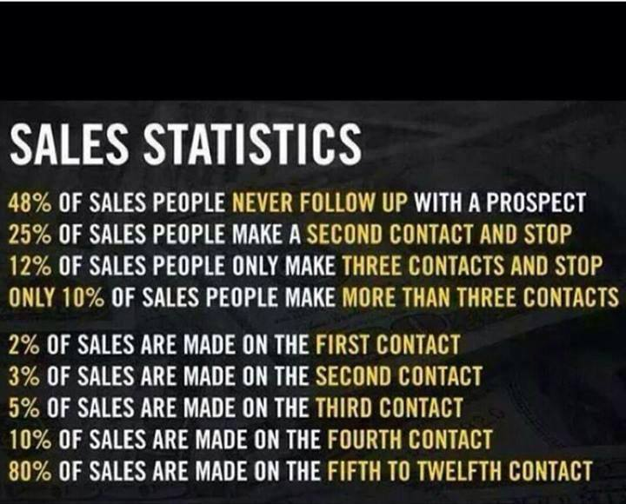Ladies, your presentation (clothing or attire) should not be THE “presentation” of the evening.  Get what I mean?  Choose the right outfit. There’s a both a professional and lovely way to dress.   If every man's eyes in the room are on her and their mind is elsewhere then they can't focus. Be mindful what is showing and if that in itself will cause minds to shift and be distracted.  
I remember in 9th grade (April talking here) and my science teacher wore really short skirts. All the boys would joke about how they weren't learning anything at all in there except anatomy! I'll never forget it as I learned a lot that year about choosing my attire. Bottom line, if people can’t focus on what you’re presenting what does that mean?    
They don’t learn.    
They don't get excited about the product.  
They don’t enroll.    
#FAIL

Instead, model other people who are successful.  Ask yourself if someone would be offended or would their concentration be broken just by what you're wearing.  You don't want to be eye candy, you want to be SOUL FOOD!  Be professional about how you present yourself so people can get what they're looking to get from your event.  
In 2015, Eric Worre of Network Marketing Pro hosted a Speakers Academy in Las Vegas. Here is a clip of him talking about how choosing what to wear can make or break you. He pulled random volunteers on stage and covered their eyes and asked the audience for a show of hands in who would enroll with that person based on what they were wearing. It sounds superficial but just watch. It's very telling and eye opening about what people think. WATCH:  <https://vimeo.com/121003349> (15 min)

MUSIC at events is very important.  You don't want a quiet and dry room, ever.  Playing music is a must. The audience has to give YOU energy and music gives the audience that life and energy/tone of the room.  Set the environment correctly with music.  Song selection should be demographic friendly and nothing profane.  Jazz is too soft and mellow. You’re not at a wedding.  Classical...people will be looking for a pillow to go to sleep.  Pick upbeat and fun music.  The volume should be appropriate.  Raise the volume as people come in so people have to just barely talk over the music. This will allow their energy to go UP and will create excitement about what is about to take place or what just happened if it's over.

Sharing with others means being EXCITED and with that means discovering your POWER VOICE.  Many people are afraid to get up in front of others and speak but here’s the reality.  When you face your fear, most of the time you will discover that it wasn’t such a big threat after all. It’s really rejection we are afraid of. You must think of failure and defeat as the springboard to new achievements on to the next level of accomplishment.  Fear does not have any special power unless you empower it by submitting to it.   You cannot expect to achieve new goals or move beyond your present circumstances unless you get OUT of your comfort zone and INTO your courage zone by trying something new.

People think you have to be bulletproof and strong to be a speaker. You do NOT.  The audience wants REAL and humbling experiences.  Something they can relate too.  We've been taught that to show weakness is death.  "Don't let 'em see you sweat".  But letting people know your fears, mistakes and weaknesses builds trust with them.  Then they're ready to listen to the things you know.  There’s incredible power in vulnerability and telling a story that has a point.  That said, never make a point without a story and never tell a story without a point.

One of the world’s most renowned speakers and Toastmasters Hall of Fame-er, Les Brown, says to stay far, far away from saying, writing or posting fruit-less words like  "umm", "uhhh", "like" and "ya know".  They’re the 4 words, he says, to avoid at all costs.   It's unprofessional and people get distracted by it.  Those words actually takes the focus OFF the power of your words to make any impact. Those 4 words literally dumb down your point you are trying to make! These "dead filler words" do not encourage people or validate them in any way.  They don’t fit into the framework of a story.  All they do is fill space.  Les Brown says we should be very purposeful and intentional with our words if we want to make a real and true impact.  Embrace language that EMPOWERS you. Not words that merely fill space.  When you have the desire to say those words, stop yourself and instead just PAUSE.  Take a silent pause.  Even if you're in from of a crowd of people. This is much more effective when speaking.  No one remembers a few silent pauses but they will remember you saying “Uhhh, umm, like, ya know” etc. multiple times.  To get these words OUT of your vocabulary, record your presentation and then go back and listen or watch it and count the times you say “Um, Uh, Like and Ya know”.   It will take time but you can do this!  Again, let’s be very purposeful with our words to make a real impact.  After all, Less Brown says that the greatest speakers use the FEWEST words.  It’s true!

Speak with power, conviction and feeling to create a listening environment.  You direct the energy of the room with your voice, conviction and movement.  Get your audience, whether in a living room or bigger venue, both physically and verbally involved.  There's something very powerful about that.  How you look at them and the quality of your voice can fire them up or put them to sleep.  The best speakers make the FEWEST words go the FARTHEST. (another Les Brown-ism) Create a new reality for those in your presence by telling YOUR story.  Stories can be used to take a person on a journey within themselves to places where they can never go by themselves.  Master storytelling requires patience, practice and persistence.  You want to master this, your story, it's important for your business.  It helps people break their own self imposed glass ceiling.  They haven't even given themselves the benefit of trying.  Your goal is to help them create the thirst where they want to drink.  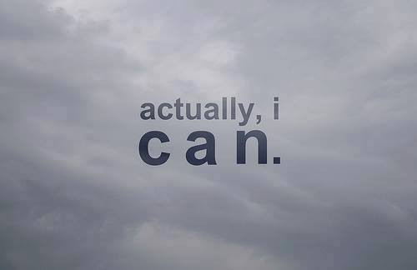

Get physically involved with your words to capture people's heart and eyes.  Physiology and the way you pause with words and emphasize words is touching.  The power of a master storyteller paints a story.  “Live full.  Die empty.” ---Les Brown.   Imagine being on your own death bed and your dreams, gifts, talents, ideas, projects or opportunities are ALL standing around your bed looking at you saying "we came to you and ONLY YOU could have given us life and now we must die FOREVER with you".  Think about that.  If you died tonight, what dreams, creativeness, opportunities, skill sets, music or idea would die with you, never to be known by the world because you didn’t share it?  Tragic! Les Brown says that “The wealthiest place on the planet is a cemetery because you'll find skills and abilities that were NEVER used.”  What if you found out today you are actually living "small" and there is SO MUCH MORE in you?  Well guess what? You have GREATNESS within you!    
Live FULL.  
Die EMPTY.  
Don’t you dare take any of those God given dreams, talents, skills, etc to your grave with you.

The passion that exudes from you about life and even Young Living is important. You want your audience to experience YOUR experience as you tell your story.

So...DO NOT be a reporter.

DO NOT be a reporter.

DO NOT be a reporter.

Come to the audience from FIRST PERSON.   Not from second person.  If it’s not your passion to change people's lives, you can't expect to move them if you're not moved yourself. Take people on a journey touching people's hearts mind and spirit.  Your tone and energy are everything.  They should FEEL what you're saying.  You want people to look within themselves. What haven't you done yet?  Where do you want to go?  On purpose and FOR a purpose.  Expanding the mind, touching the heart and igniting the spirit---that's what we are doing here.  You must create a SIGNIFICANT EMOTIONAL EVENT.  When you do that with your words, gestures and stories, people get transformed.  DO NOT underestimate you or your voice, there's people waiting to hear it!  People should feel the NEED to make the change you're offering.  You have the ability to touch people that don't even know you.   Have a conviction about success and believe you deserve it.  Because of your courage a lot of lives will be changed.  Be committed to yourself and those you care about to make this business work for them.  When you come to discover your POWER VOICE  you learn to use your body and eyes, facial expressions and to become an intuitive speaker and read your audience.  Losing and stopping is NOT in your DNA. Got it? You were born to win!  Honor yourself with your work.

Part 2: WATCH

Watch this 17 min presentation by Les Brown. He’s one of the top 5 speakers in the world---WOW!  He’s a world renowned and very powerful speaker, influencer and encourager!

<https://www.youtube.com/watch?v=SII6p569fpA>

***OPTIONAL*** VIDEO---58 minute video by Les brown-----so good!!  This is not part of today’s homework and is optional.  I promise it’s WELL worth your time if you have extra time in your day to watch or bookmark to watch later.    <https://www.youtube.com/watch?v=ph_eaqY57ec>

Part 3:

Go to Youtube.com and type in “Les Brown” and bookmark videos that look interesting by him.  Come back to them as you have time.  We could all use more Les Brown in our lives on a daily and consistent basis!  He is also on Facebook with a page to “like” and you can also follow him on Periscope.

# DISCUSS:  What were your 4 biggest takeaways from today’s assignment?  How many times did you hear Les Brown say “Umm”, “Uhhh”, “Like”, or “ya know”?  ANSWER:  Zero

SQUAD members, if you're going through this bootcamp with others in a Facebook group, post your answers to the discussion questions there.

CADETS, get a notebook that you can journal in.  Write the question and an answer to each day's Discussion questions. This notebook will be an excellent reference to lean on in the future as your business grows.

**DAY THIRTEEN:**

**TIME MANAGEMENT**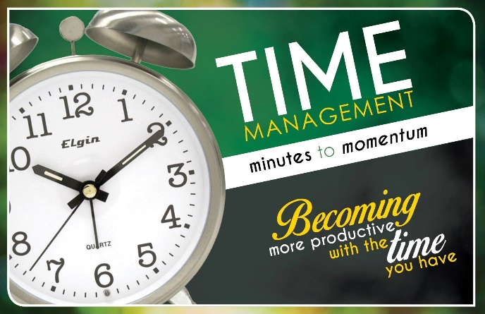

There are only 3 ways to spend time: thoughts, conversations and actions/activity. Our personal life and our work life will be composed of those three items.  If you can take your time into your own hands, then you are in control and you decide where you want to go to.  Practicing time management has lots of benefits. Once you get the hang of it, you can work more productively, learn faster and play more.    
  
What if you had 1 extra productive hour in a day? That would yield 5 extra hours a week and around 250 hours in a year.  That is 6 extra weeks a year of more time to be productive at work, time with your family and leisure activities or hobbies, or whatever you need that extra time for.  When time management gets priority you can control the way your life goes. You will be more organized and it will prevent deadlines from becoming a problem. You will also gain more freedom because you're less dependent of outside events to control your time because, instead, you will control your time and you will tell IT where to go.

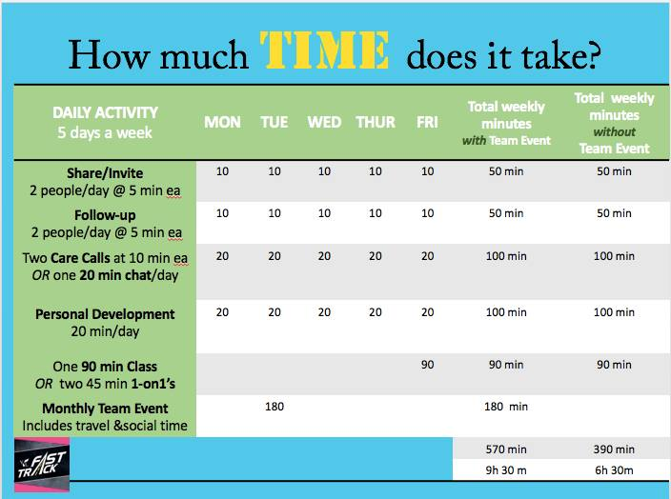  
  
  
  
  
  
  
  
  
  
  
  
  
  
  
  
  
  
Listen to this call by April Pointer, on “Time Management”.  You'll need to visually reference the graph above during the call.

<http://stme.in/kmse4bPw2>  (38 min)

**DISCUSS**

1. How do you manage your time currently?  Is this working for you?
2. What was your biggest takeaway from the call that you can implement right away to impact your home and business life?
3. By using the graph to focus on income producing activity, how will this free up time for you?

|  |
| --- |
| SQUAD members, if you're going through this bootcamp with others in a Facebook group, post your answers to the discussion questions there.  CADETS, get a notebook that you can journal in.  Write the question and an answer to each day's Discussion questions. This notebook will be an excellent reference to lean on in the future as your business grows. |

**DAY FOURTEEN:**

## The Mental Game

Probably one of the most difficult things to overcome as we "build our empires" is our MIND. The doubts, fears, past mistakes, team members that let us down, the negative committee in our heads whispering things to us. 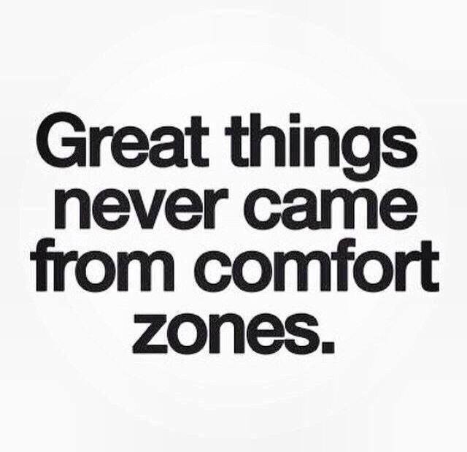

It’s easy, when things aren’t going your way, to have a pity party and give into those voices, the rationalizations, the disappointments and the rejection.

Thankfully, this call has several ideas on how to come out AHEAD of the mental game. Because sometimes, you just have to fake it, until you make it.    
  
Listen to this YL Fast Track call with April Pointer interviewing Brian Carruthers, author of best selling book “Building an Empire”, so you can start MAKING IT!  Brian's book, "Building and Empire" is a generic book about network marketing based on his decades of experience. Brian has made tens of millions of dollars in network marketing and has authored a few books. His Facebook page is <https://www.facebook.com/fostermentor/?fref=ts>.  Go "like" it and pay attention to his posts.  He's one of the best of the best in our profession.  Take notes, this is a fantastic lesson today!

Today’s call is an hour so if you need to break up the call to get it all and take notes, do that.

**LISTEN**: <http://www.ylfasttrack.com/wp-content/uploads/2015/09/12-18-14-AP-BC-abundance.mp3> (65minutes)

**DISCUSS**:    
1. What are 3 nuggets of information from this call that really hit home with you so much that you can’t wait to implement them in your business?  
2. Is there anything Brian or April mentioned that you're already doing right that you've had success with? Share that success story.

|  |
| --- |
| SQUAD members, if you're going through this bootcamp with others in a Facebook group, post your answers to the discussion questions there.  CADETS, get a notebook that you can journal in.  Write the question and an answer to each day's Discussion questions. This notebook will be an excellent reference to lean on in the future as your business grows. |

**DAY FIFTEEN:**

**RELATIONSHIPS**  
**This whole Young Living thing....it's truly ALL about relationships.  Never underestimate the power of relationships. They require empathy AND attention.**

**Listen to this call on Relationships with April Pointer (RCD) and Niccole Perez (now a Diamond)** [**http://stme.in/dQFq3EyGT**](http://stme.in/dQFq3EyGT)



[**www.volunteerspot.com**](http://www.volunteerspot.com) **is the site Niccole uses so her team leaders can schedule phone calls with her at a time that is convenient for BOTH of them. She blocks time off that she can make herself available and they choose a time out of those blocks that works for them. There will always be people who just call you and think you have all the time in the world to talk, and this can eliminate some of that.  Scheduling a call with someone will show them that you value both your own time as well as theirs.**

**DISCUSS**

1. **There is a well known quote by Theodore Roosevelt that states, "People don't care how much you know until they know how much you care". Be honest with yourself: on a scale of 1-10, how good are you at keeping and maintaining your relationships with people in your YL downline - (business builders, wholesale members, or customers)?**
2. **Based on this call, how important do you think care calls are?**
3. **What is your biggest challenge with care calls (time, nervousness, etc.)?  Do you think this is a real challenge/hurdle or is it just an excuse?**

**BONUS POST for those participating in a SQUAD**

We are a few weeks in and I am LOVING the interaction and responses I have heard so far! I bet many of you are getting out of your comfort zone and into your courage zones and having SUCCESS already!  I hope you are all reading each other’s responses to each assignment - that’s how we grow!  
Make sure you’re in your upline’s Facebook group that teaches and supports business building in their downline. It's your GYM membership. Operation Silver is an EXCLUSIVE training just for those who want to build a business with Young Living. It's your PERSONAL TRAINER.

That all said, I would like to remind you of the commitment to be in your Squad group. Your leader and peers need to hear from you EACH DAY on the daily post comments. If you are not ready to make that commitment, please let them know. The group is exclusively focused on those really wanting to learn, grow, and build during our time together.

|  |
| --- |
| SQUAD members, if you're going through this bootcamp with others in a Facebook group, post your answers to the discussion questions there.  CADETS, get a notebook that you can journal in.  Write the question and an answer to each day's Discussion questions. This notebook will be an excellent reference to lean on in the future as your business grows. |

**DAY SIXTEEN:**

**Congratulations, you have made it halfway through bootcamp! Give yourself a big pat on the back!****Part 1: READ & WATCH**

Today's assignment is about Busy Work vs. Income-Producing Activities!    
The more organized and focused you become on your income producing activities, the more effective you will become. This will provide plenty of room for your business to GROW and free up your own time! The objective is to become more productive while also being more peaceful.    
  
Let’s talk about getting more efficient with our time by attacking income producing activities with purpose so that we make the most of the time we commit to growing our business.  Time is the one commodity we never get back. “Money mistakes can be corrected.  But once time has passed, it is gone forever.” - John C Maxwell

Chasing a paycheck prior to developing duplicable habits will lead to a BIG black hole that can be really hard to climb out of. Mistakes are expensive sometimes. You can't be the one doing all the work. This is about a lot of people doing a little bit every day. Staying organized will help immensely.  Lack of organization and focus is the #1 enemy of success.  
  
Let’s consider starting each day by determining the top 3 tasks to accomplish that are Income Producing Activities.  Focus only on just those 3 things that day for your Young Living business.  Figure out how much time you are willing and able to commit to each of those tasks before they get pushed to the next day and allow nothing else to dominate your time or attention during those hours.  Fight and protect those minutes with as much fervor as you would if you knew your next goal rank or item on your vision board was dependent on accomplishing that task.  If you are currently a Star rank with Young Living, and your goal is to become a Silver, ask yourself: “Am I attacking this task(s) with as much determination and professionalism as I would when I am a Silver?”  Every minute of distraction (Facebook newsfeed, random phone calls and texts, television, etc.)  is a minute less spent on the important tasks.  
“Your results are the product of either personal focus or personal distractions. The choice is yours.” - John de Lemme

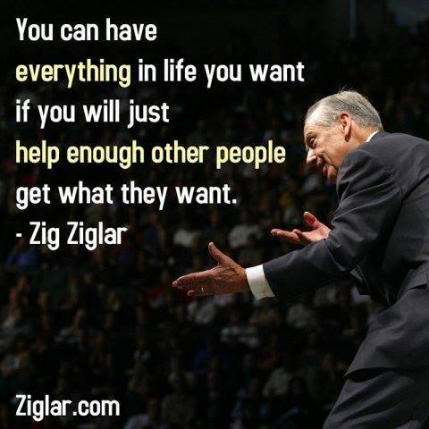

*Here are a few suggestions when tackling your Income Producing Activities (IPA):*

*Place your phone and other electronic devices on ‘Do Not Disturb’.    
*Set up your 'Do Not Disturb' hours to recur daily during the week for those hours dedicated to Income Producing Activities.

*Use a timer to commit short bursts of focused time to each of your IPAs. If you stay focused and don’t complete the task by the end of the time allotted, re-evaluate if that task should be assigned additional time the following day, or if you would like to give it additional time at the end of the day.

*What Determines an Income Producing Activity?*

Those tasks that involve:

1. Introducing (sharing and inviting) new people to the product and/or business side of Young Living.
2. Following up with those wanting to enroll, those who just received their kits and those you know who need help deciding what to order next. There's a lot to choose from!
3. Supporting your members via Care Calls or chats with your leaders to strategize.
4. Classes or events.
5. Personal Development--this doesn't seem like an IPA but it truly is because it influences the way you manage your business, time and IPA's.

*Non-Income Producing Activities include:  checking your virtual office / downline, posting on Facebook, responding to messages, organizing your office and products.  While this may be part of running your business and connecting with your team, these activities should not be considered ‘income producing’.

*How Can I Prioritize and Make the Most of My Income Producing Activities?*

Make your list of 3 IPAs the night before and watch your to-do list get COMPLETED!  Planning your day in advance will allow you to start your day with an advantage!  Another way to prioritize your daily IPAs is to do those things that produce the income to fulfill your ‘Why’ FIRST! Many people like to do time blocking. This is setting a block of time with a plan in place of who to call, email, text and plan out your week. Making a list each night of your top 3 priorities the next day is helpful. 3 is a good number to accomplish because you will go to sleep that night knowing you've been fruitful that day in your business. If you reply to people all that the same time instead of here and there throughout the day, it will help you be more productive. April talking here...."We like to use our phone calendar and a paper planner to plan our weeks. A phone calendar synced to my husband's phone/computer/tablet so that we all know each other's schedule for appointments. These are all that go on our calendar. Everything else like brainstorming, ideas, planning and such go in a paper planner. My top 3 things to do every day go in a planner. This literally helps me maintain my daily happiness because I can set realistic goals or tasks for myself this week and go to bed at night knowing I was productive that day by doing my top 3 tasks for my business. Multiply that times 5 days a week and that's 15 important things I knocked out that week."

Today's action-oriented steps are focused toward helping you to achieve your goals and to GROW.  By finding balance/harmony in all areas of your life, you will enjoy more fulfillments in your achievements.

How do you plan to accomplish your goals? Let’s listen to the legend and leader in our profession of network marketing, Jim Rohn, as he discusses ways we can work harder on *ourselves* than we do on our job. “If you work hard on your job you can make a living, which is fine. If you work hard on yourself, you can make a fortune, which is super fine.”

<https://www.youtube.com/watch?v=YuObJcgfSQA> (9:51)

**Part 2: LISTEN & PRINT**

Listen to this YL Fast Track call as Crown Diamond, Melissa Poepping, covers how you can use her Abundance Tracker tool to assist you in moving toward success and achieving your goals. An Abundance Tracker helps you keep track of all your growth in Young Living, month by month, and lays it in front of you for a visual. Click on this link to access the Abundance Tracker Training Call, as well as the Abundance Tracker PDF file below it.

**LISTEN**:<http://stme.in/k1LliZHKA>  (24:29 mins)

**PRINT:** Abundance Tracker FORM<http://www.essentiallysweethealth.com/uploads/2/9/5/2/2952134/abundance_tracker_2a.pdf>

Note: You will need to print out an Abundance Tracker for each calendar year that you have decided to make Young Living a business. If you have been in Young Living for several years, we suggest you go back and fill out an Abundance Tracker for each year you have embraced the business and shared Young Living with others.

**DISCUSS:**

1. Share other ways you can create boundaries to help yourself stay focused on your IPAs.
2. What is your most exciting takeaway from Melissa Poepping’s call on the Abundance Tracker (AT)?

***OPTIONAL*** bonus video for today:

Jim Rohn speaks on individual’s abilities to accomplish goals. One must have enough reasons!  “It’s the journey, not the money.” - Jim Rohn (12:58 minutes)

<https://www.youtube.com/watch?v=6hCFGhmL2HI>  
  
***OPTIONAL*** viewing on organizing with salt made millionaire Susan Sly.

* 1. Share your thoughts on minutes 5:27 thru 8:26

<https://www.youtube.com/watch?v=qP3GhoRrs9Q>

|  |
| --- |
| SQUAD members, if you're going through this bootcamp with others in a Facebook group, post your answers to the discussion questions there.  CADETS, get a notebook that you can journal in.  Write the question and an answer to each day's Discussion questions. This notebook will be an excellent reference to lean on in the future as your business grows. |

**DAY SEVENTEEN:**

|  |  |  |
| --- | --- | --- |
| |  |  | | --- | --- | | This business is fundamentally about relationships as you learned just a few days ago. Our goal is to build relationships before we talk about our product with people.  It is a basic principle behind any successful marketing strategy. This is a people business. Actually, it is a relationship business.  **LISTEN**  Listen to this call by Diamond leader, Jen Jordan, call on **Care Calls**. Care Calls are phone calls to let your team know you really do care and want to help them succeed in their health and/or business.  <http://stme.in/SK23vLZJQ> (23 minutes)    One step that moves leaders forward is their ability to follow-up effectively andhttps://gallery.mailchimp.com/456e6897822452d2e7f6afdea/images/d759aaa4-9d71-4540-b133-2fc2c23f4e18.jpg strategically. Following up should be something that leaders take pride in. It shows you Care!  Your goal is to listen and let your members know you care about them and their well-being. We have 2 ears and 1 mouth for a reason.  Listen.  Find their need and then find a fit solution for it.  This business is much more about character development, humility, and relationship building than anything else. When someone purchases their oils because they trusted you and believed in the information you shared with them, then they will also value when you take time to call and check in on them.  Care Calls are a great way to build a relationship with your team, increase OGV, and potentially create new business builders. It’s a way to spread your charisma for YL and fire others up about it too.   If you have noticed someone hasn't ordered in a while, a Care Call is in order. If you're trying to build volume in a particular leg or overall, reaching out via Care Calls is a great way to let your team know you're on their side and want to help them reach their health goals. Try to keep calls at 20 minutes or less. Wrap up the call when you feel it's appropriate. Part of being a great leader is developing a relationship with your team. Social media private messages only go so far. It is so important to let someone hear your voice and let them know you care about them and want to help them. If they don’t trust you, they won’t share with you.  Be excited and radiate that passion for YL and helping others.  One thing to keep in mind when making a Care Call is simply that you love your oils and you know how much they help you. If you are focused on the idea that it may earn you more money and then you feel bad that you may receive money when you know they may not have a lot of money themselves, then your facts and understanding need some re-adjustment. I know my life is better because of essential oils. I know that my family and I will live healthier lives because of oils. I know I would give my entire bank account to live longer and so would most people. I have saved a lot of money using essential oils in lieu of things I used to use. I love them I can't help but tell others about them. Because I've helped the company do their advertising for them, they pay me generously, and that has changed a lot over the years I've been sharing.  The bottom line is you are doing them a GREAT favor by encouraging them in using their oils and putting value in them with the words you speak. Stop apologizing for sharing something AMAZING with them! You are not being pushy. You and essential oils are a blessing. If you don't know and believe that, neither will they.  When making Care Calls, or even talking to someone at the park, remember this conversation starter: FORM.  We talked about this just a few days ago in bootcamp and it's worth mentioning again here. It can be used in many area of life! A care call isn’t to be carried out in an “interview style”.  This is merely subject matters to bring up organically.  F - Family: Ask them where are they from or do they have family in the area (Small Talk)  O - Occupation: What type of work do you do for a living? How long have they been doing it?  R - Recreation: What do you like to do for fun? I am new to the area and wanted to know what is there to do for fun here?  M - Message: Based on what  https://gallery.mailchimp.com/456e6897822452d2e7f6afdea/images/32d99909-1203-452b-a958-14fe839937bd.jpg  you've just shared with me, I have something that I think would help you because it’s helped me/someone I know. If they seem financially motivated, you can always say, “Off the record, do you keep your options open in terms of making any money outside of your current career"? Share about YL’s unprecedented growth right now, any debt you’ve been able to pay off, and how the market is NOT saturated. Less than 5% of the world even knows what essential oils are. Plenty of people out there!  Here’s an example of some things you can say in a Care Call:  "Hi, this is ____ and I’m part of your Young Living Leadership support along with ______ (their sponsor/enroller). Just wanted to call and say hi and see how you’re doing. From time to time, I like to reach out to my group and find out which oils have been your favorite and what’s left in your collection. What have you used them for?  Or if you have some you've not opened yet, maybe you’re unsure how to use them, I would be happy to help you with those unopened bottles.  Would it be ok if I shared some of my favorite uses with you?”  “Out of curiosity, when you came to Young Living you must have had some health goals. Are there any you might like to share with me? What have you been able to accomplish with YL’s products?  I’d be glad to help you with what I know. My promise to myself is to help my team reach their health goals. Would it be ok if we talk about what you have right now and make a plan for you in how to use them?”    **Other Things You Could Say:**   * What oils do you have at home? * My job is to make sure you’re ordering smart. * Let me help you build your next order. Let’s start with the oils you’re out of. You obviously like those. * If/Since ____ is out of stock, let’s try ______instead. * What do you think about trying some ______?? * I remember when I first started ordering essential oils, I thought I should start out with the Aroma Complete collection and then realized how overwhelming  and counter-productive that might be, since I wouldn’t have any oils left to order, and it would be more difficult to get to know each oil and what I like most about it.     A few years ago it used to take an average of 3 call attempts to reach someone by phone.  Now, the average is 6-7 times.  Unfortunately most people only make 1-2 attempts.  The best times to call are either between 8:30AM - 11:30AM and/or 3:00PM - 5:00PM.  For parents or those working full-time jobs, these times correlate with after school starts or on their way home from work.  The worst times to call for stay-at-home parents are during nap time for little ones, so typically 11:30AM - 2:00PM.  Sometimes you'll find a parent that nap time is ideal for them.    **How to Share ESSENTIAL REWARDS on a Care Call**  “Can I share with you how I am able to get cheaper shipping and 10-20% back on my wholesale orders?  Have you heard of Essential Rewards? If you're ordering $200-$400 every few months, I’d love to offer you some insight into this option, because when you break these sporadic orders up into 50PV orders instead, you’ll receive cash back in points toward free products.  It’s the same budget, just spread out monthly.  You can cancel anytime. It’s a 50PV per month commitment, and you get to change your product and processing date every month. You earn cash back on each purchase, plus you get lower shipping rates. Transfer buy what you’re already buying at your local store and just purchase comparable products from YL instead to support your own business.The oils have saved me so much money. I have a great short video that touches on how to set this up and the benefits if you’re okay with me emailing or messaging it over to you?”  (Wrap up the call and follow through with sending the video if requested.) Grab a Youtube video that explains essential rewards. There's lots to choose from. Or use the one below.  **Essential Rewards Video:** <https://youtu.be/vsV_tf-IcPI>  Bookmark this video to have on hand for future use!    ASSIGNMENT: Complete 1-2 Care Calls after listening to the YL Fast Track call. When you talk with a person, find out what they want. Do they want vibrant health, another income source (freedom for more family time), pure and healthy products for their family, to see the world, etc? As leaders, it is our goal to help people focus on and achieve their goals. Most people have a financial goal or constraint and it's easy to gently approach how sharing a great product can start to generate an income.https://gallery.mailchimp.com/456e6897822452d2e7f6afdea/images/409ae418-8371-4607-9b47-22de66f1d2a7.jpg  Look at your downline viewer in Virtual Office and keep calling your members until you reach and speak with at least two members. Take notes on each person you speak with and mark the date. Refer back to the notes each time you call them, so that you have create a relationship and can build off of your last conversation. If your Care Call is to someone active in your downline who is building a team, you may choose to take notes of their interests so that you can gift them something special and unique to them for accomplishing a big goal or to celebrate something special down the road. See what happens!  **DISCUSS:**  Share or journal how your two to three Care Calls went. How did you feel before, during and after they happened? Don't be discouraged if you left voice mails. Wait a few days and call back if they haven't returned the call. Or shoot them an email that you tried to call and would love to talk to them about ______.  NOTE: Some of you may not have anyone in your organization yet, and that’s ok! You will be making these calls soon enough!   |  | | --- | | SQUAD members, if you're going through this bootcamp with others in a Facebook group, post your answers to the discussion questions there.  CADETS, get a notebook that you can journal in.  Write the question and an answer to each day's Discussion questions. This notebook will be an excellent reference to lean on in the future as your business grows. | | |

**DAY EIGHTEEN:**

|  |  |  |
| --- | --- | --- |
| |  |  | | --- | --- | | Today is a very fun assignment!  It’s time to Step Outside Your Comfort Zone, and into your COURAGE ZONE and FOCUS! For today’s post, we will be setting goals for both 30-days and 6-months.  But first, WATCH this video with Network marketing EXPERT, Eric Worre. He shares the underlying reasons why many people never hit their goals, or lose their desire a few months later. You will be shocked that missing the target has nothing to do with aptitude, environment, desire, nor the goals you set. There is a better way to achieve your goals and your motivation matters!  <http://networkmarketingpro.com/1/2016> (22 min)      A 30-day goal should be something that is attainable through action, yet stretches you beyond your comfort zone and moves you toward your longer term goal. This 30-day goal can easily be repeated month to month, making you more efficient and confident.  Examples may include:  -Make 2 Care Calls every Monday, Tuesday and Thursday.  -Host 2 in-home Introduction to Essential Oils classes.  -Hand out or mail samples to 10 new prospects a week and follow up with them within 24 hours.    A 6-month goal will be larger than your 30-day goal.  This goal should make you squirm just a little! It should have a larger and more powerful ‘WHY’ behind it.  This goal is one that you will want to share with your trusted inner-circle to keep you accountable.  Examples may include:  -Help 2 new business builders to their next rank  - Increase my monthly team growth by X% (use your Abundance Tracker!)   * Complete X number of in home classes * Accomplish Silver in 6 or Silver Rank     **Part 1 - 30-Day Goal Setting**    Write your 30-day goal at the very top of the paper with a specific goal date and include:  -Your WHY behind this Goal  -Goal to Complete  -Goal Date  -Support Images (see Support Image Ideas below)  -Resource List (see Resource List Ideas below)  -Action Plan (see Action Plan Ideas below)  https://gallery.mailchimp.com/456e6897822452d2e7f6afdea/images/c6c874d3-fa50-4a57-9059-ea205dbb152a.jpg  Make two copies:  One is taped to your bathroom mirror  One is taped or located near your computer Pray over them daily. Speak positive things over them like "I will be Silver by August" (for example). If you say it enough you will begin to believe it and then you will do what it takes to make it happen because the drive and dedication will be there.    **Part 2 - 6 Month Goal Setting**    Write your 6-month goal at the top of the paper with a specific goal date and include:  -Your WHY behind this Goal  -Goal to Complete  -Goal Date  -Support Images (see Support Image Ideas below)  -Resource List (see Resource List Ideas below)  -Action Plan (see Action Plan Ideas below)      **Support Images Ideas:**  -Power Words  -List of reasons why you will never give up! (What is the alternative?)  -A list of freedoms or activities you will enjoy once each goal is accomplished  -Print out a list of inner-circle support / friends that you can call on when you need a little encouragement  -Scriptures / Prayers  -Vacation destination images  -A sign that says “I AM DEBT FREE!”  -Write a check to yourself, to a charity, or to a company for a debt you owe with a specific date and tape it on your goal paper, with a commitment to be able to cash it or use it to pay off a debt, give to your choice charity on that date.  Note: No amount is too small or too big.  This is used for motivation!    **Resource List Ideas:**    Famous motivational quotes - (Search Google!)    The names of books & audios you can refer to for support (now is an excellent time to build your library if you don’t yet own any). Just choose 1-2 to start with. Here's some of our favorites.  Note: Many of these books can be purchased as audio books or in podcast form to listen to while driving, while folding laundry, while cooking, or on a water proof blue tooth radio! Keep a notebook handy to write down key points (not while driving obviously!). Here are some of our favorite resources.    Building an Empire:  <http://www.buildinganempirebook.com/about-the-book/>    The Four Year Career: Young Living Edition by: Richard Bliss  <http://www.blissbusiness.com/Store/Products/9448.aspx>    Magnetic Influence by: Dani Johnson  <http://shop.danijohnson.com/magnetic-influence>  Road to Royal by Debra Raybern  <http://growinghealthyhomes.com/road-to-royal/>  Circle of Success by Monique Mclean <http://shop.youinfuse.com/collections/circle-of-success>  The Compound Effect  <http://www.amazon.com/Compound-Effect-Darren-Hardy/dp/159315724X/ref=sr_1_1?ie=UTF8&qid=1423342156&sr=8-1&keywords=compound+effect>    Rock Your Network Marketing Business by: Sarah Robbins  <http://www.amazon.com/ROCK-Your-Network-Marketing-Business/dp/1884667260>    Go Pro by: Eric Worre  <http://www.amazon.com/Go-Pro-Becoming-Marketing-Professional/dp/0988667908>    Building Your Network Marketing Business Audio - Jim Rohn  <https://yoursuccessstore.com/audio-cds/building-your-network-marketing-business-audio-cd.html?refid=younglivingsuccesstools>    Entreleadership by Dave Ramsey  <http://www.amazon.com/EntreLeadership-Practical-Business-Wisdom-Trenches/dp/1451617852/ref=sr_1_1?ie=UTF8&qid=1423342226&sr=8-1&keywords=entreleadership+by+dave+ramsey>    **Action Plan Ideas:**  Specific steps you will COMMIT to completing. Get specific and hold yourself accountable! Below are some suggestions. Pick a number of them is reasonable for you. Don't pick A LOT and set yourself of for failure. Instead pick a few and set yourself up for SUCCESS!    Commit to reading (insert #) of training books or chapters per (time frame and titles)  Commit to listening to two educational or training audio CDs /conference calls per  (time frame and titles)  Commit to (insert #) of Care Calls per (time frame and names)  Commit to (insert #) of Introductory Classes per (time frame)  Commit to (insert #) of view of your downline per (time frame) with a list of things you are looking for (people missing a paycheck, people ordering each month not on Essential Rewards, etc.)  Commit to updating your Abundance Tracker each month/quarter  Watch (insert #) of motivational videos per (time frame)  Commit to a percentage increase in total number of members on your team or a percentage increase in OGV per month. Break the percentage increase into percentage increase needed per week  Commit to hosting consistent online classes for your team ([GotoWebinar.com](http://gotowebinar.com/) , [zoom.us](http://zoom.us/), [spreecast.com](http://spreecast.com/), Google + Hangout).  Example topics for calls may include: Business Training for Your Team, Essential Rewards, DIY Oily Project/ Make-N-Take, Intro to Essential Oils 201, Raindrop, etc.  Commit to attend the LIVE EVENTS including the Young Living International Grand Convention in Salt Lake City, UT! COMMIT TO NEVER GIVE UP!!    **DISCUSS**     1. Share either your 30-Day or 6-Month Goal 2. Think back to something you accomplished as a child or in the past.  What helped you push through to accomplish that goal during times of struggle or when obstacles presented themselves?      |  | | --- | | SQUAD members, if you're going through this bootcamp with others in a Facebook group, post your answers to the discussion questions there.  CADETS, get a notebook that you can journal in.  Write the question and an answer to each day's Discussion questions. This notebook will be an excellent reference to lean on in the future as your business grows. | | |

**DAY NINETEEN;**

**Oola - How to Find Balance in an Unbalanced World**

Have you ever felt that you excel in some areas of your life, while other areas are left in a state of complete drought?

What is OOLA?    
Oola is the concept of living a well-balanced life, and a term embraced by both Dr. David Braun and Dr. Troy Amdahl, co-authors of their international best selling book Oola: Find Balance in an Unbalanced World.

The Oola guys have helped to inspire Young Living in developing 9 exclusive Young Living Essential Oil Blends, called the Infused 7.  The oils include the  7 F’s: Field, Fun, Family, Faith, Friends, Finance andFitness plus the 2 enhancing oil blends: Balance and Grow.

View a snapshot of what Oola is about in their book intro video here: (5:02 minutes)

https://m.youtube.com/watch?v=Qo2yjUQsTT0

**PART 1: LISTEN**

Listen to this YL Fast Track call with the Oola guys, Dr David Braun and Dr Troy Amdahl:

http://stme.in/bwf72MPG9  (41 minutes)

**PART 2:** **3 STEPS TO OOLA LIFE**

Complete the questions in each of these 3 steps to living an Oola Life: (OolaWheel, OolaPlan, OolaLife) to help develop goals and a plan for a more well-balanced life:

http://www.oolalife.com/3-steps-to-oola/

**PART 3: CONNECT**

Facebook: Oola Facebook page for daily inspiration and wisdom here -<https://www.facebook.com/OolaLife>

Periscope: @OolaLife

**DISCUSS:**

1. Is it okay to be in a season of opportunity?  If so, have you expressed this to those people and relationships nearest and dearest to you so that they understand where you are at during this season?  If not, how might you go about discussing this with them in an open way?

# **Listen back to the Oola Call (**[**http://stme.in/bwf72MPG9**](http://stme.in/bwf72MPG9) **—> Min 11:04-12:10) and envision what life will look like for you at the high achiever levels.  Can you see, feel and touch with your mind what your life will look like with these areas in balance at this point in your Young Living career?  Share a snapshot view of what your ideal daily life may look like with the 7 areas of your Oola Life in balance once you have achieved the rank / income you desire.  Place images reflecting these thoughts on a vision board.**



|  |
| --- |
| SQUAD members, if you're going through this bootcamp with others in a Facebook group, post your answers to the discussion questions there.  CADETS, get a notebook that you can journal in.  Write the question and an answer to each day's Discussion questions. This notebook will be an excellent reference to lean on in the future as your business grows. |

**DAY TWENTY:**

You are at the end of FOUR incredible weeks of investing in yourself!  GREAT JOB! One of the key factors that separates those who are successful in the network marketing industry and those that aren’t - is consistency!  I realize you are making the choice of trading out time you could be spending on other things, to instead invest in growing yourself so that you can help support empowering and growing others around you.  This portion will be on empowerment and it is going to help you understand the value of believing in yourself, holding yourself accountable, and being a leader that encourages and instills these same values to your team!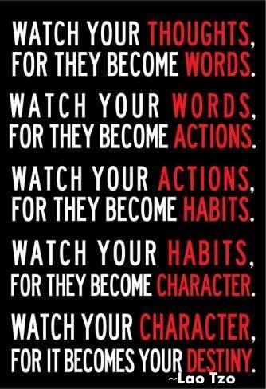

**PART 1: READ & WATCH (1 minute)**

Think back to a time when someone said they believed in you or gave you the nudge to 'Go For It!'.  How did it make you feel?  Do you realize the impact you can have on those around you and within your team by reflecting the same belief in them? Be their cheerleader! People crave praise. Watch this quick 'Minute with Maxwell' to see just how powerful your belief in your team can be to their success!

<https://www.youtube.com/watch?v=uknOpZ7mx8c>

**PART 2: READ & WATCH (15:34 minutes)**

Part of empowering your team and yourself as a leader, is learning how to streamline and multiply your time and efforts.  We are all given the same 24 hours in each day, yet some seem to be able to manage and accomplish more than others. Why is that and how do they do it all? How are they so productive?

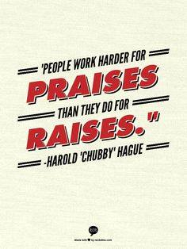Watch this video on how to Supercharge your productivity:

How to super charge your productivity like a NINJA! <http://arealchange.tv/2014/03/episode-92-how-to-supercharge-your-productivity-with-ninja-like-accuracy-quick-easy/>

**PART 3: READ**

Read over these brief but powerful tips to help you increase your productivity.

21 Tips to Become the Most Productive Person You Know

<http://www.robinsharma.com/blog/09/become-the-most-productive-person-you-know/>

**DISCUSS:**

1. Make a list of 3 people in your organization to become a focal point over the next month whom you will pour into with encouragement and belief. Get to know their desires and WHY.  Send them a card in the mail expressing your belief in their dreams and goals. Set a reminder on your phone each week to pray for and then call, email, or text them.
2. Share your top 1-2 tips from the "21 Tips to Become the Most Productive Person You Know" article. Which ones can you commit to?

|  |
| --- |
| SQUAD members, if you're going through this bootcamp with others in a Facebook group, post your answers to the discussion questions there.  CADETS, get a notebook that you can journal in.  Write the question and an answer to each day's Discussion questions. This notebook will be an excellent reference to lean on in the future as your business grows. |

**DAY TWENTY ONE:**

It's a SHORT day today! YAY!  
Jim Rohn is one of the all time favorite veterans (and just a pure genius) of the network marketing industry.  He says, “We get paid for the VALUE we bring to the marketplace".   Are you spending time doing things that are monotonous, lack value or meaning, or tackling so many tasks that the VALUE of the time we have committed to the day just completely diminishes?  Many times we find ourselves distracted online, pulled in many different directions, without specific tasks or goals to tackle.  Today, we’ll listen to Jim Rohn as he explains that we don’t get paid for TIME spent doing these things.  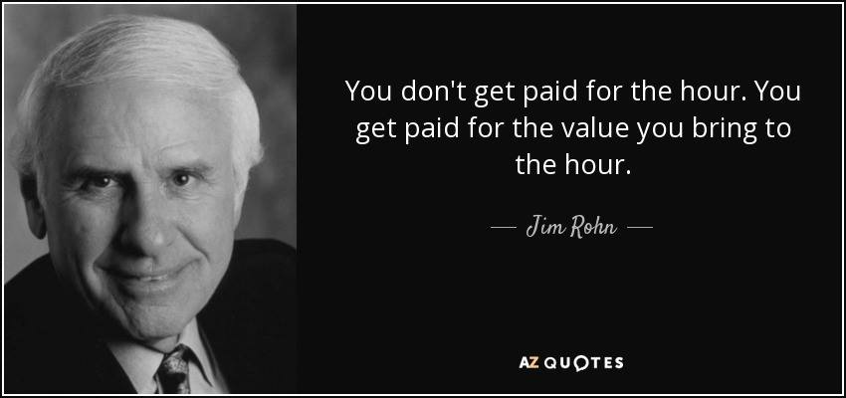

**WATCH:**

Listen in as Jim Rohn explains how to increase your VALUE in a way that is understandable even to children.

<https://www.youtube.com/watch?v=XY5nulJAIn4>

**DISCUSS:**

1. Is it possible to become three times as valuable as you now are and make three times as much money in the same time?  Share your takeaways from Jim Rohn’s video on how waiting on a raise vs. bringing more value can increase your position in the marketplace in less time.  
  
2. DO you ever have someone say "$160 is too much to spend on the Premium Starter Kit."?  If so, you haven't properly shared the TRUE value of the kit with someone.  If they knew the true value of it, they'd be chomping at the bit to get it for $160.  The PSK's retail value is well over $300 for the lowest price kit we have.  Share 2 things you might say to potential new members that brings VALUE to the already tremendously discounted Premium Starter Kit.   
  
3.  List out specific things you can do within Young Living that will increase your own value as a leader of your Young Living organization.   
  
***Since today was a super short lesson, take the next 30 minutes to chew on past lessons or get caught up on something you might be behind in with your business.  Then make some plans   
on what you can do to get more organized with your time so you can become more productive the time you have so you don't get behind. 

SQUAD members, if you're going through this bootcamp with others in a Facebook group, post your answers to the discussion questions there.

CADETS, get a notebook that you can journal in.  Write the question and an answer to each day's Discussion questions. This notebook will be an excellent reference to lean on in the future as your business grows.

**DAY TWENTY TWO:**

OVERCOMER!  
As a leader, we must be prepared to empower our team and that can be a difficult task to empower others when you find yourself stuck in your own state of "self-sabotage".  Ever been there? No worries, we all have been there. Some of you reading this today are stuck right in the middle of it. It is the silent language spoken inside your own head that can do more damage than anything else in this business. However, no one will ever know but YOU.    
  
Today, let's read through this blog entry where we will identify self-sabotaging behaviors, learn which healthy replacement behaviors there are and learn how to ask better questions that can change your thinking patterns. Choose today to be an OVERCOMER!

**READ:**

<http://blog.iqmatrix.com/overcome-self-sabotage>  
  
**READ**: Gold leader, Sara Mcfall, wrote this wonderful blog post about how to CRUSH negative thinking. It is so important to identify this because it can be a very powerful influence in our life and we CAN overcome negative thinking to operate in a more optimistic mindset for all avenues of life, not just in business. Who doesn't need more positive influence?  
<http://tinyurl.com/hjad5c9>

**DISCUSS:**

Journal or share any self-sabotaging behaviors you have allowed to creep into your life and/or leadership.  Write down the following questions on a piece of cardstock 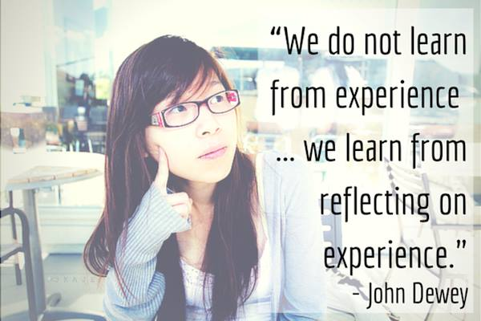and place it in your workspace.  When dealing with self-sabotaging thoughts and moments in leadership, identify a healthy replacement behavior and then ask yourself these questions:

What have I learned from this experience?

What would I do differently given another chance? What could the potential benefits be?

SQUAD members, if you're going through this bootcamp with others in a Facebook group, post your answers to the discussion questions there.

CADETS, get a notebook that you can journal in.  Write the question and an answer to each day's Discussion questions. This notebook will be an excellent reference to lean on in the future as your business grows.

**DAY TWENTY THREE:**

Communicating with your team members in a language that they understand is a critical step in becoming an effective leader. At Young Living events, many times you may be asked your leadership “COLOR” style.  This is in an effort for the other person to know what you enjoy and don’t enjoy - what may offend you and vs. what you embrace.

**LISTEN**

<http://stme.in/wmzN1MF3S>

This 30-minute call features Young Living member, Jacob Adamo, who wrote the book, Full Spectrum Success.  He highlights some key words that we have all know very well, but they will take on a whole new meaning!  Listen in as Jacob shares with us highlights from each personality type on the spectrum from dysfunctional to highly functional.

**PARTICIPATE**

After listening to the call, hop over to his website and take your personality test for free: <https://www.jacobadamo.com/personality-colors-quiz/>

Take note of your own personality style.  How accurate is it to understanding and portraying the real you?  Your likes / dislikes?  Strengths and weaknesses? This is not a system for stereotyping, but for recognizing positive and strong traits in order to communicate with people in the way to which THEY will respond best. This is to speak "their' language. This allows us to capitalize on our strengths and learn how to predict a person's response in certain situations. It is also effective in dealing with our members. It’s VERY important to speak others’ language when talking business with them. Some are highly focused on numbers and statistics while others just want to save the world and help as many people as possible with our oils. I cannot tell you how valuable this tool is. Knowing your leader's dominant 1-2 colors will greatly increase effective communication with them.  Find out their dominant color personality and make a notes of it. . Before you call them, look up their color, and then you'll know how to best motivate and respond to them. Also know this, it's never ok to pull you own color card out and use it as an excuse. "Oh but I am a yellow so I am in-decisive, so you make the decision.....oh but I am a red, I just want you to get to the point for goodness sake already...oh I am a blue, if this isn't fun you'll lose me in 3, 2,..oh look, a squirrel........oh but I am a green, I just need all the data and reasons WHY so please provide me with that."  No, we can't use it as an excuse card.  What we should do instead is learn how to bring out the best out of our leaders and members by being able to peg them for their 1-2 dominant colors.  That way you can encourage, inspire and lead them effectively.

Pages 1-3  in this link discuss meanings as well as good oil suggestions for each color personality. Thank you to Evangeline and Tom Reed for this content.

<https://docs.google.com/file/d/0B-V7KeI5ZCxCQUNNbERtNEN4alE/edit>

**DISCUSS:**

Which is your dominant color?  Do you agree or disagree with your results?

How might someone motivate YOU within your color?  How might your relationships and team thrive if when you notice dysfunctional traits popping up as you are leading your team, you stop and find a functional trait to trade it out for?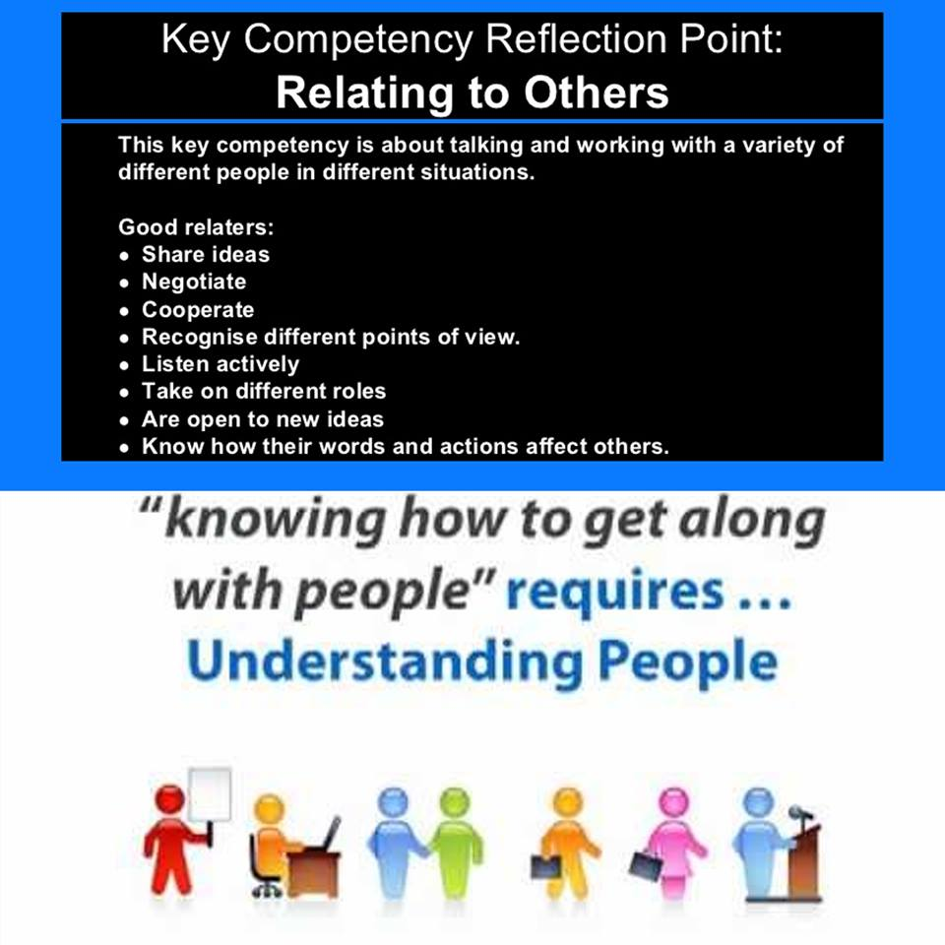

# Challenge: Offer this call and link to test your top 3-4 business builders.  Take note of their personality color on an index card and write down 2 ways of how you might best encourage or even motivate them as their leader.  No business builders yet?  Ask 3 leaders within your upline support and do the same.

SQUAD members, if you're going through this bootcamp with others in a Facebook group, post your answers to the discussion questions there.

CADETS, get a notebook that you can journal in.  Write the question and an answer to each day's Discussion questions. This notebook will be an excellent reference to lean on in the future as your business grows.

**DAY TWENTY FOUR:**

You are getting ready to launch your newly acquired skills to a new level of success.  With great success comes great responsibility.  And with great responsibility, life can get a little hectic and stressful.  Let’s talk about Handling Stress & Setting Boundaries.

**Part 1**

Listen to this call by Leah Rockwell on the “Top Ways to Handle Stress”   (11:06)

<https://youtu.be/E44tXfdfeP4>

**Part 2**

Create Your Work Hours    
We all need a schedule - for when you wholeheartedly, with no interruptions, dedicate a specific time, on specific days, to work your Young Living business.  Fit Young Living around your schedule - this is the beauty of our business model.  When will you work?  When will you NOT work?  Write down your work hours and post them on a wall, mirror, the fridge, some place where you are constantly reminded of your boundaries and expectations.  And stick to them!  This is VERY #Oola! It keeps God first, family second and business third.

**Part 3**

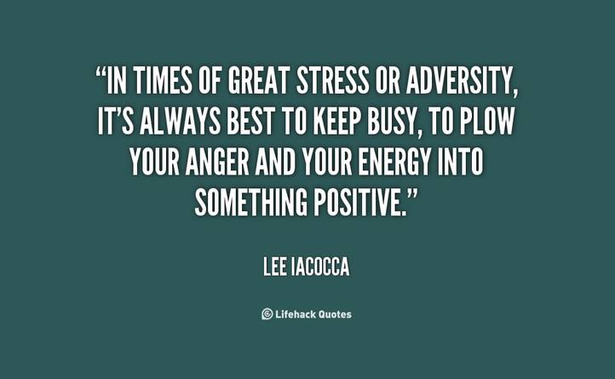Is it stressful when someone says they can’t afford the kit and you hear it over and over and over? This all has to do with VALUE. If they say it costs too much, then you haven't built the value in the kit both monetarily or healthwise. If it’s a common response, stop and ask an upline, mentor or friend to hear the way you share with others. They can help you tweak things you're saying.  Talk about what’s new and exciting, express passion for what you do and what the oils have done for you and your family, share the value of the company, why we have our own farms and how much money you’ve saved.  Most importantly. listen for THEIR needs and offer a solution with the oils.  Be honest, speak from the heart.  $160 is an absolute steal for this kit!  They are spending $160 SOMEWHERE, you just need to find their WHY their family should use the oils and share the value of the kit.

**DISCUSS:**

1. What are some boundaries you feel you need to create?
2. What are boundaries that have worked thus far for you?
3. What are some ways you handle stress?

SQUAD members, if you're going through this bootcamp with others in a Facebook group, post your answers to the discussion questions there.

CADETS, get a notebook that you can journal in.  Write the question and an answer to each day's Discussion questions. This notebook will be an excellent reference to lean on in the future as your business grows.

**DAY TWENTY FIVE:**

|  |  |
| --- | --- |
| |  | | --- | | Committing to Your Business - and in the right way is extremely important when “launching” your business.  **Part 1**  Listen to this YL Fast Track call with Royal Crown Diamonds, April Pointer and Adam Green. Their topic is all about “Commitment and Recognition”.  <http://www.ylfasttrack.com/wp-content/uploads/2015/09/1-21-15-AP-AG.mp3>(39 minutes)    **Part 2**  Contacting and Inviting—like Brian Carruthers says in his book “Building an Empire”, the name of this game is contacting people and inviting them to classes or scheduling 1 on 1’s. One thing he emphasizes is listening.  We want to be great listeners. Asking a lot of questions. We don’t want to be sales-y, instead, we want to meet people where they are at. Whether that’s staying healthy and well or because they need some $$$...quickly. Make a commitment to continue reaching out to people, building relationships, inviting them to classes and events, and build a strong foundation.  These are the fundamental basics we should be committed to doing at every moment.  https://gallery.mailchimp.com/456e6897822452d2e7f6afdea/images/9cf5cafa-2dc2-440c-8445-a01f167f2945.jpg         **DISCUSS:**   1. What specific wording could you use to reach people in a product driven manner? Or, if you think someone is ready right away for the opportunity, what do you say? (this is RARE for YL leaders to lead with the opportunity as we are a product driven company but some people do it successfully) Squads...Read through the comments all of you answer, this may give you some ideas to add to your mental vault. 2. How can you use Social Media to your advantage?  What are some do’s and don’ts? 3. What ideas do you have for Recognition for various ranks? How did it make you feel when your upline recognized your accomplishments or failed to recognize you? Keep both in mind as you create your own recognition for your team.     SQUAD members, if you're going through this bootcamp with others in a Facebook group, post your answers to the discussion questions there.  CADETS, get a notebook that you can journal in.  Write the question and an answer to each day's Discussion questions. This notebook will be an excellent reference to lean on in the future as your business grows. | |

**DAY TWENTY SIX:**

Have No Fear!  Leading with Confidence, Inspiration and Positivity

**Part 1**  
We all want to live in the No Fear Zone—Fear of Rejection, fear of looking foolish and fear of success. Listen to this short call by Platinum leader, Leah Rockwell, as she talks about fears we may face but must overcome in this business. “Have no FEAR”. <https://youtu.be/nBqEt9TGW5U>(6:43)

**Part 2**

A “No Fear” confidence can not only help you grow your business, but be an inspiration to others.  As we get ready to launch our business, watch this excellent video on “How Great Leaders Inspire Action”.  Simon Sinek has a simple but powerful model for inspirational leadership all starting with a golden circle and the question "Why?" His examples include Apple, Martin Luther King, and the Wright brothers…”

Have a listen and let your communication style and “why” be forever impacted.

WATCH (18 min)

<https://www.ted.com/talks/simon_sinek_how_great_leaders_inspire_action?source=facebook#.VOdjwO7Fmb9.facebook>

**DISCUSS:**

1. What are some things you struggle with in terms of fear, and how can you overcome them?
2. In Simon Sinek’s video, what was your one biggest takeaway?

SQUAD members, if you're going through this bootcamp with others in a Facebook group, post your answers to the discussion questions there.

CADETS, get a notebook that you can journal in.  Write the question and an answer to each day's Discussion questions. This notebook will be an excellent reference to lean on in the future as your business grows.

**DAY TWEENTY SEVEN:**

Congratulations on making it to the last week of Operation Silver! We are excited that you are taking your personal success, as well as the success of your team to a higher level.  Whatever you do as a leader, your team will duplicate that, including your ethics, morals, and integrity.  Being a good leader means you lead by example.   A team is only as good as it’s leader, so be the kind of leader that you want your whole organization to emulate.  Be the sponsor that YOU would want to have leading YOU! The fact that thousands upon thousands have been successful in YL, means you can be the next one!

**Part 1: LISTEN**

Listen to this YL Fast Track call on “Developing Your Leadership Skills (Pt 2)”, by Melissa Poepping, YL Crown Diamond. [About 2 minutes of this call was based off the old kit (different oils and different price.)  The info surrounding it is still very valid and relevant today.](http://stme.in/FdIM3fyrw)

(27:01)

<http://www.ylfasttrack.com/wp-content/uploads/2015/07/12-16-Melissa-Leadership-p2.mp3>

**DISCUSS:**

1. What things will you start implementing in your team and team leaders?  What do you want duplicated on your team?

2. Do you setup your approach that gives a yes or a no answer?  Do you have problems getting people to commit?  What open ended question could you ask to leave the ball in their court yet feeling like they want to answer?

SQUAD members, if you're going through this bootcamp with others in a Facebook group, post your answers to the discussion questions there.

CADETS, get a notebook that you can journal in.  Write the question and an answer to each day's Discussion questions. This notebook will be an excellent reference to lean on in the future as your business grows.

**DAY TWENTY EIGHT:**

|  |  |
| --- | --- |
| |  | | --- | | Developing Your Leadership Skills, pt 2    **Part 1: LISTEN**  The more you do something, the better you become at it.   https://gallery.mailchimp.com/456e6897822452d2e7f6afdea/images/ab4a7739-f4d0-4daa-8046-c87f7e4899d9.jpg  We aren't ALL born with talent and a God given ability to be great at this network marketing thing from Day 1.  Teaching classes, getting educated on the oils, social skills that make people want to follow the leader and then branch off on their own to lead their own teams are all things that take practice.  It's a matter of conditioning and perseverance.  You might be scared the first time!  It's easier to embrace that reality that average can become good which then becomes...GREAT!    https://gallery.mailchimp.com/456e6897822452d2e7f6afdea/images/20077022-a64b-4b2e-a11e-d39aed258785.jpgIt may yield mistakes and failures but KEEP GOING!  You'll get really good at this because of the effort you put in.  The foundation is the hardest part to lay down but once you do, then it's gets easier as it becomes a bigger part of you.  We must push through it in the beginning...like a ship does.  The MOST fuel is used in the launch.  And then....you break through and the smooth sailing starts!!    Listen to this YL Fast Track call on “Developing Your Leadership Skills Pt 3”.  <http://www.ylfasttrack.com/wp-content/uploads/2015/07/1-6-Melissa-Leadership-part3.mp3>  (28 minutes)    **PART 2:**  WATCH this video:  [http://www.fostermentor.com/becoming-good](http://www.fostermentor.com/becoming-good/) (8 minutes)    **DISCUSS:**  1.  Before today, what was your perception about success and God-given ability?  How has that changed?  2.  What is the fear that you need to face head-on?  3.   How will action dispel that fear?  SQUAD members, if you're going through this bootcamp with others in a Facebook group, post your answers to the discussion questions there.  CADETS, get a notebook that you can journal in.  Write the question and an answer to each day's Discussion questions. This notebook will be an excellent reference to lean on in the future as your business grows. | |

**DAY TWENTY NINE:**

|  |  |
| --- | --- |
| |  | | --- | | Empowering New Business Buildershttps://gallery.mailchimp.com/456e6897822452d2e7f6afdea/images/9e93f51b-d459-45b1-810d-3ab23de8baea.jpg    Part 1: WATCH  Operation Silver is coming to a close. WOW! Congratulations on making it this far! Nothing is more motivating than the support of others, working with your crossline, and learning how others built their business. #TeamYL    This YL Fast Track call on Empowering New Business Builders goes over this in depth with (now) Diamond leader Niccole Perez.  Listen to it here:(35 minutes) <http://www.ylfasttrack.com/wp-content/uploads/2015/07/2-27-April-Nicole-Empowering-Bus-Builders.mp3>    **Part 2: WATCH**  Has anyone ever asked you if YL is a pyramid scheme?  Watch this video<https://m.youtube.com/watch?v=zZiw15VgWoI>(5 minutes). It should have you laughing by the end at how ridiculous the accusation even is! You may need to take some notes on how to respond when people give you the excuse that network marketing is a “pyramid scheme.”  Also check out this great blog on 8 facts about working with an network marketing company.  It’s a fantastic read with great tips!   <http://thepenningtonpoint.com/2015/07/8-facts/>    **Part 3:**  https://gallery.mailchimp.com/456e6897822452d2e7f6afdea/images/f5659bab-044e-4032-80dd-c27d31092776.jpgBookmark this site to reference stock images to create some of your own graphics if you're creative like that.  “Looking for stock images can be a tedious and expensive task, especially if you stick to the standard sites. But there are other sites out there, and many of them are better than the status quo. Here are eight sites with great stock photos.”  <http://www.entrepreneur.com/article/237094>      **DISCUSS:**  1. As you’re getting ready to finish up Operation Silver and prepare for a new month, what things will you be doing with your team that you have learned these last several weeks? Create that list and be ready to go full force after bootcamp ends.  2. Have you ever been asked if YL is a pyramid scheme?  What will you answer now?  3. Do you have a favorite website for stock images to make graphics with?  SQUAD members, if you're going through this bootcamp with others in a Facebook group, post your answers to the discussion questions there.  CADETS, get a notebook that you can journal in.  Write the question and an answer to each day's Discussion questions. This notebook will be an excellent reference to lean on in the future as your business grows. | |

**DAY THIRTY:**

The Law of Explosive Growth

**Part 1:**

Watch John Maxwell as he talks about The Law of Explosive Growth.  He is an internationally respected leadership expert, speaker, pastor of pastors and author who has sold more than 19 million books. 19 million! Do you think he has some wisdom to share?  
He discusses developing leaders and developing followers at a pastor’s conference he did on leadership here in the following link.  There are so many great nuggets in this video because many times we find ourselves “counseling” our members instead of equipping and empowering them.  He teaches how to do that and everything he says can be applied to a YL business, even though he’s addressing a group of pastors.  Leaders who develop LEADERS will devote attention to the top 20%. Leaders who develop FOLLOWERS will devote attention to the bottom 20%.    If you give the top 20% of your members 80% of your effort you’ll get an 80% return.  WOW!  But look at this.  If you give the bottom 20% of your members 80% of your effort, you’ll only get 20% return.  No bueno. Read that a couple of times till that sinks in and then watch this video.  (27 minutes)

<https://www.youtube.com/watch?v=ZLkRPmYBtX8>

**Part 2:**

Watch this video on enrolling 20 people in 30 days by Eric Worre from Network marketing PRO. He's an expert at this stuff and offers the most phenomenal training for our profession. Here he talks about going on a major blast NOW so you can cruise on the volume LATER.  (23 minutes)

<https://www.youtube.com/watch?v=AS3Asc2NYXE&feature=youtu.be>

**DISCUSS:**

1.  Equipping people on their strengths, do you do this?    
2. Can you focus on the top 20% of your organization?    
3. What specific things can you do to reach out to them and let them know you’re there to equip and encourage them?

SQUAD members, if you're going through this bootcamp with others in a Facebook group, post your answers to the discussion questions there.

CADETS, get a notebook that you can journal in.  Write the question and an answer to each day's Discussion questions. This notebook will be an excellent reference to lean on in the future as your business grows.

**DAY THIRTY ONE:**

|  |  |
| --- | --- |
| |  | | --- | | WOW! YOU DID IT! You've officially completed bootcamp and are now an Operation Silver VETERAN! You have been drinking from a fire hose throughout this training. It's been HARD!  It's been a lot of WORK!   But look at where you are now compared to the weeks ago when you began!  Are you ready to spread your wings and DO THIS?! https://gallery.mailchimp.com/456e6897822452d2e7f6afdea/images/27d35c03-9e01-421a-8cfa-ae3596b3038c.jpg    The following video is **ALL about YOU** as you go out and start a ripple effect around Young Living Essential Oils and the vibrant health it can bring all across the planet.  Think of all the lives you're about to touch and change forever....for the better!  It's called the "Butterfly Effect" and **YOU** will leave a lasting ripple on the earth! Oh, grab some kleenex before you watch...    **WATCH:** (9:45): <https://www.youtube.com/watch?v=mo6fBAT8f-s>    So, CONGRATULATIONS TO YOU!  We are so proud of you for completing bootcamp!  Some of you may have hit a new rank, enrolled several more people, boosted your confidence enough to host a class or got really learned on some clear cut ways to grow by actively participating in Operation Silver and taking what you learned these last several weeks to the field and to your business. WOW!  After seeing your results, it is clearly worth it. We love watching all the success that has come for so many of you. God is good!  Bootcamp is intense, a major commitment, and a lot of work. This is a prime example of working SMARTER, not harder.https://gallery.mailchimp.com/456e6897822452d2e7f6afdea/images/d48f2b7a-2ac1-4aee-bd5a-42db715cf135.jpg After planting your seeds by investing in yourself these last several weeks, prepare for some great growth, firmly rooted with all the foundational tools you will need to succeed.  It has been a pleasure guiding you through Operation Silver Bootcamp. May you find wellness, purpose, and abundance in all aspects of your life.    Thank you for participating in this journey with us through dialogue, comments, and interactions.   **MISSION ACCOMPLISHED!** Time to get out there and get it done, friends!    DISCUSS: **1. What is your perspective now as a business builder TODAY in comparison to when you started bootcamp?** **2. What was your favorite lesson in bootcamp?** **3. Was there something that was an "ah-ha" light bulb moment?**     SQUAD members, if you're going through this bootcamp with others in a Facebook group, post your answers to the discussion questions there.  CADETS, get a notebook that you can journal in.  Write the question and an answer to each day's Discussion questions. This notebook will be an excellent reference to lean on in the future as your business grows. | |